

DATA STRUCTURES & ALGORITHMS
23CSE203
LAB MANUAL
Submitted By
Name | CHANDRA SEKHAR MATCHA
Roll No. | AV.SC.U4CSE25035
Year/Sem/Section | 2nd year /Sem-3/CSE-A
Credits | 05

S.No. | Title | Page No.
1) | Week-1:  1A) Rocket launch systems display the countdown of before launch instead of using a loop implement the countdown using the recursion write a recursion Python program to display the countdown from n to 1 followed by launch.  1B) Banks calculate the growth of an investment using compound interest. The formula requires calculating powers, which can be implemented recursively. Write a recursive Python program to calculate P^n (power), where P = Principal growth factor, n = number of years.  1C) An HR department stores employee IDs in a list. Develop a recursive program to search for a given employee ID. Write a recursive function to search for an employee ID in a list.  1D) In a logistics company, the number of possible ways to arrange n different parcels is calculated using the factorial formula. Develop a recursive program to calculate the factorial of a given number.  1E) Write a recursive Python program to print the first n terms of a Fibonacci series. | 3-12
INDEX

WEEK-1

1A) Aim: Rocket launch systems display the countdown of before launch instead of using a loop implement the countdown using the recursion write a recursion Python program to display the countdown from n to 1 followed by launch.

Program:
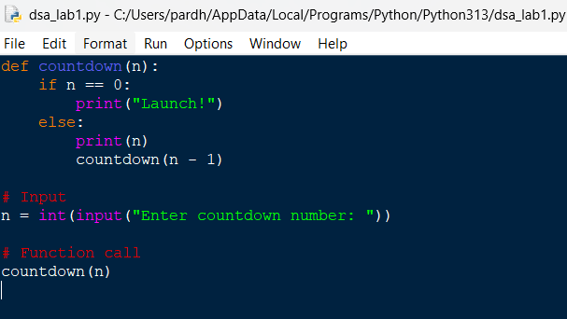
Output:
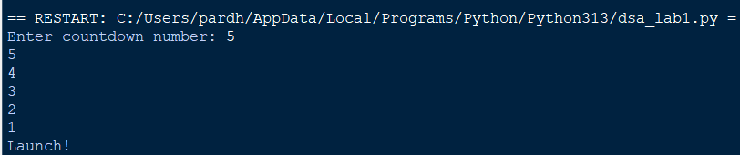

Explanation:
- def defines the countdown() function.
- input() accepts the countdown value from the user.
- int() converts the input into an integer.
- countdown() starts the recursive countdown process.
- if checks the base case (n == 0).
- else executes when the condition is False.
- print(n) displays the current countdown number.
- countdown(n - 1) recursively calls the function with the value decreased by 1.
- print("Launch!") displays the launch message when the countdown reaches 0.
- The program demonstrates the use of functions, recursion, conditional statements, input, and output to perform the countdown.
Error Table:
S.No. | Errors Observed | Rectification
1) | Invalid (non-numeric) input entered by the user. | Enter a valid integer as input.
2) | Missing base case (if n == 0) causing infinite recursion. | Include the base case to stop recursion .l
3) | incorrect indentation leading to an Indentation Error | Maintain proper Python indentation.
4) | Missing colon (:) after def, if, or else. | Add the required colon (:) after statements.
5) | Calling countdown(n) instead of countdown (n - 1), causing infinite recursion. | Decrease the value by 1 in each recursive call using countdown (n - 1).

1B) Aim: Banks calculate the growth of an investment using compound interest. The formula requires calculating powers, which can be implemented recursively. Write a recursive Python program to calculate P^n (power), where P = Principal growth factor, n = number of years.

Program:
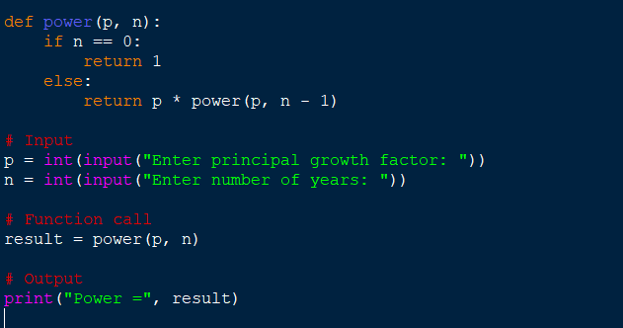
Output:
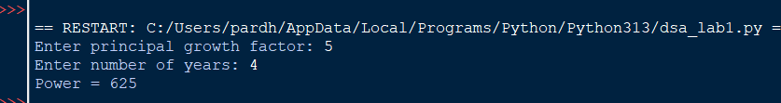

Explanation:
- power() is the recursive function that computes P raised to n.
- The base case is n == 0, which returns 1 (any number to the power 0 is 1).
- The recursive case multiplies p with power(p, n - 1), reducing n by 1 on each call.
- float() allows the principal growth factor to be a decimal value.
- input() collects the values of P and n from the user.
- Each recursive call is stacked until the base case is reached, then the results are multiplied back up the call stack.
- print() displays the final computed value of P^n.
Error Table:
S.No. | Errors Observed | Rectification
1) | Missing base case (n == 0) causing infinite recursion. | Include the base case to stop recursion.
2) | Entering a negative value for n causes the recursion to never reach 0. | Restrict input to non-negative integers or handle negative n separately.
3) | Using int() for P truncates decimal growth factors. | Use float() to accept decimal values for P.
4) | Incorrect indentation leading to an IndentationError. | Maintain proper Python indentation.
5) | Calling power(p, n) instead of power(p, n - 1), causing infinite recursion. | Decrease n by 1 in each recursive call using power(p, n - 1).

1C) Aim: An HR department stores employee IDs in a list. Develop a recursive program to search for a given employee ID. Write a recursive function to search for an employee ID in a list.
Program:
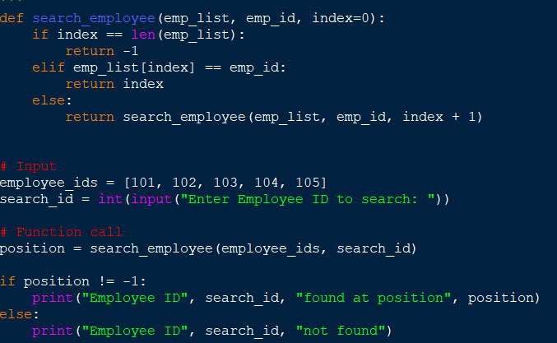
Output:

Explanation:
- search_employee() is the recursive function that searches the list one index at a time.
- The base case index == len(emp_list) means every element was checked and the ID was not found, so it returns -1.
- The second condition checks if the current element matches the employee ID being searched.
- If not matched, the function calls itself with index + 1, moving to the next employee in the list.
- employee_ids is the list of employee IDs stored by the HR department.
- input() and int() collect the employee ID to search for from the user.
- The if-else block reports whether the employee ID was found and at which position.
Error Table:
S.No. | Errors Observed | Rectification
1) | Missing base case (index == len(emp_list)) causing infinite recursion. | Include the base case to stop recursion when the list is exhausted.
2) | Invalid (non-numeric) input entered by the user. | Enter a valid integer as input.
3) | Calling search_employee(emp_list, emp_id, index) without incrementing index, causing infinite recursion. | Increase index by 1 in each recursive call using index + 1.
4) | Incorrect indentation leading to an IndentationError. | Maintain proper Python indentation.
5) | Searching an empty list without handling it, giving a confusing result. | Add a check for an empty list before searching.

1D) Aim:In a logistics company, the number of possible ways to arrange n different parcels is calculated using the factorial formula. Develop a recursive program to calculate the factorial of a given number.
Program:
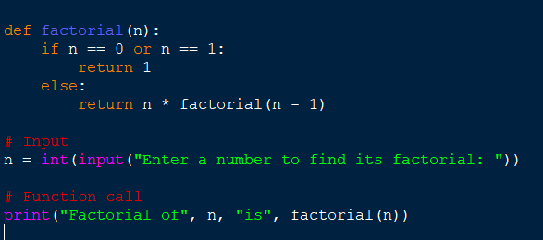
Output:

Explanation:
- factorial() is the recursive function that computes n! (n factorial).
- The base case is n == 0 or n == 1, both of which return 1.
- The recursive case multiplies n with factorial(n - 1), reducing n by 1 on each call.
- input() and int() collect the number whose factorial is to be found.
- Each recursive call is stacked until the base case is reached, then the results are multiplied back up the call stack.
- print() displays the number of possible arrangements (the factorial value).
Error Table:
S.No. | Errors Observed | Rectification
1) | Missing base case (n == 0 or n == 1) causing infinite recursion. | Include the base case to stop recursion.
2) | Entering a negative number, for which factorial is undefined. | Restrict input to non-negative integers.
3) | Invalid (non-numeric) input entered by the user. | Enter a valid integer as input.
4) | Incorrect indentation leading to an IndentationError. | Maintain proper Python indentation.
5) | Calling factorial(n) instead of factorial(n - 1), causing infinite recursion. | Decrease n by 1 in each recursive call using factorial(n - 1).

1E) Aim:Write a recursive Python program to print the first n terms of a Fibonacci series.

Program:
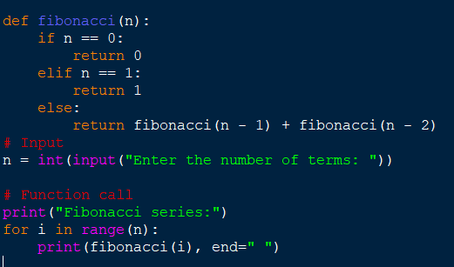

Output:
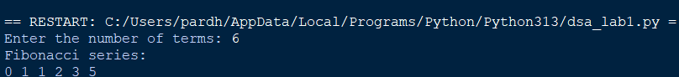

Explanation:
- fibonacci() is the recursive function that returns the nth Fibonacci term.
- The base cases are n == 0 (returns 0) and n == 1 (returns 1).
- The recursive case adds fibonacci(n - 1) and fibonacci(n - 2), following the Fibonacci rule.
- input() and int() collect the number of terms to be printed.
- The for loop calls fibonacci(i) for each index from 0 to n - 1.
- print(..., end=" ") displays each term on the same line, separated by a space.
Error Table:
S.No. | Errors Observed | Rectification
1) | Missing base cases (n == 0 and n == 1) causing infinite recursion. | Include both base cases to stop recursion.
2) | Entering a negative number of terms. | Restrict input to non-negative integers.
3) | Invalid (non-numeric) input entered by the user. | Enter a valid integer as input.
4) | Incorrect indentation leading to an IndentationError. | Maintain proper Python indentation.
5) | Using fibonacci(n - 1) - fibonacci(n - 2) instead of addition, giving wrong terms. | Use addition, fibonacci(n - 1) + fibonacci(n - 2), as per the Fibonacci rule.

WEEK-2

2A) Aim: Write a python program to perform linear search on the given input.
Program:

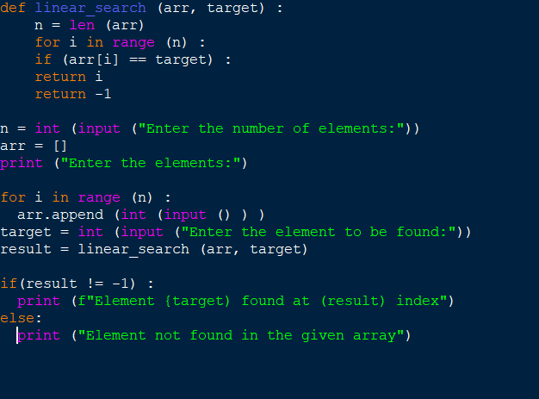
Output:

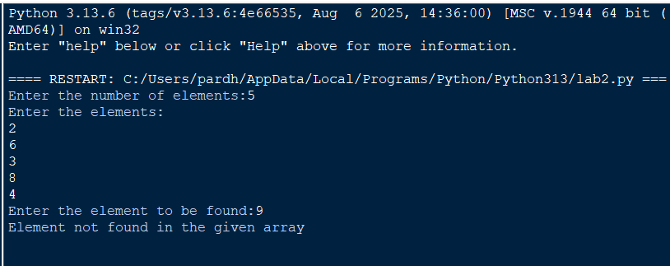

Explanation:
- linear_search(arr, target) sequentially iterates through arr to check each element against target.
- for i in range(n): iterates through array indices from 0 to n-1 sequentially.
- if arr[i] == target: checks for a match and returns index i if found.
- return -1 executes when the target element is absent from the array.
- arr.append(int(input())) converts user input to integers and builds the array.
- if (result != -1): displays the index where the element is found or prints a "not found" message.
Error Table:
S.No. | Errors Observed | Rectification
1) | Invalid (non-numeric) input entered by the user. | Entered a valid integer as input.
2) | Incorrect indentation leading to an Indentation Error | Maintained proper Python indentation.
3) | Missing colon (:) after def, for, if, or else. | Added the required colon (:) after statements.
4) | ValueError when passing non-integer strings to int(input()). | Ensure user input consists of valid integer characters.
5) | IndexError caused by accessing an array index out of bounds. | Ensure loop bounds do not exceed len(arr) - 1.

2B) Aim: Write a python program to perform binary search on the given input.Verify by taking sorted array and unsorted array as input.
Program:
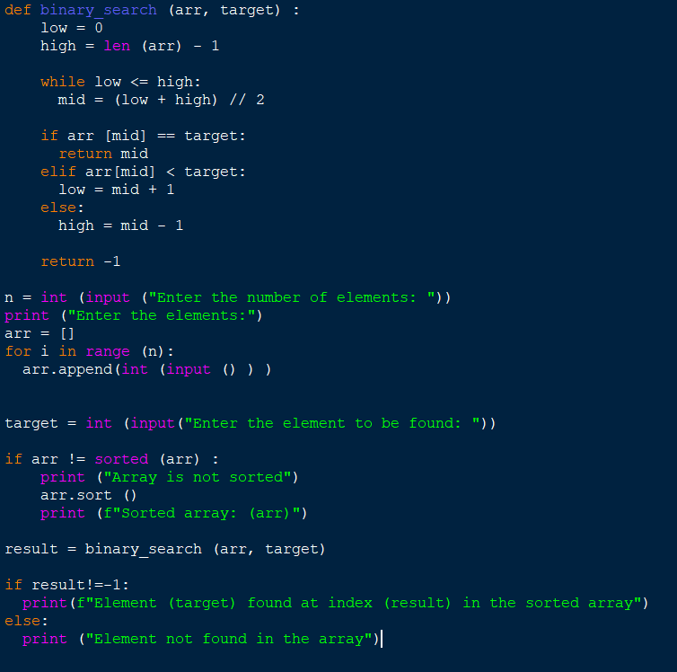
Output:
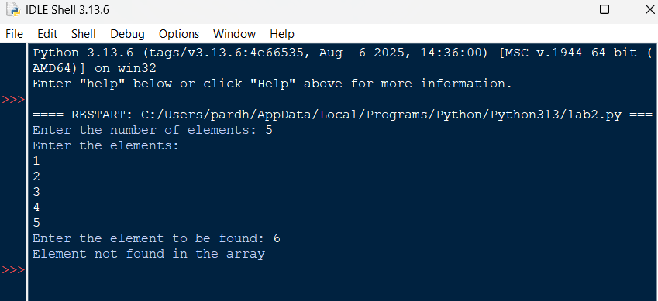
Explanation:
- binary_search(arr, target) uses a divide-and-conquer strategy on a sorted array.
- while low <= high: runs as long as the search boundary contains valid elements.
- mid = (low + high) // 2 computes the middle index using integer division.
- if arr[mid] == target: returns mid if the target is found at the middle index.
- elif arr[mid] < target: updates low = mid + 1, otherwise sets high = mid - 1.
- arr.sort() ensures the input array is sorted before executing binary search.
Error Table:
S.No. | Errors Observed | Rectification
1) | Performing binary search on an unsorted array leading to incorrect results. | Sort the array using arr.sort() before applying binary search.
2) | Using floating-point division / instead of integer division // for calculating mid, causing a TypeError. | Use mid = (low + high) // 2 for integer index calculation.
3) | Incorrect loop condition (low < high instead of low <= high), missing target when low == high. | Change the condition to while low <= high:.
4) | Incorrectly updating pointers like low = mid or high = mid causing an infinite loop. | Use low = mid + 1 and high = mid - 1.
5) | Invalid (non-numeric) input entered by the user. | Enter a valid integer as input.

WEEK-3
3A) Aim: Write a python program to sort an array using selection sort and take the elements as input from user;
Program:
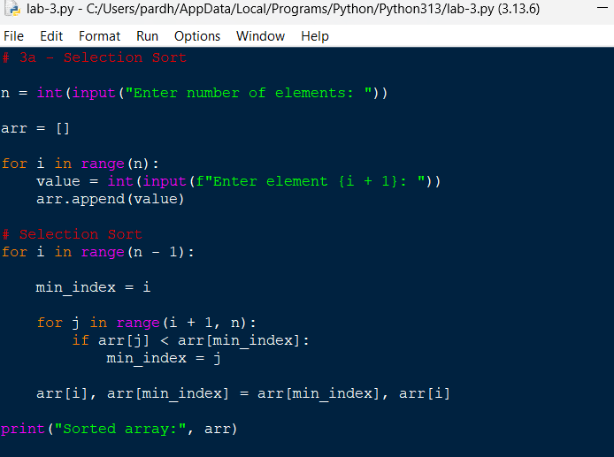
Output:
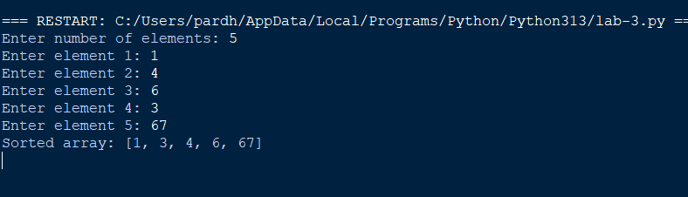

Explanation;
Took the number of elements from the user.
• Created an empty list arr.
• Used a for loop to take each element individually.
• min_index stores the position of the smallest element.
• The inner loop searches for the smallest element in the unsorted portion.
• Swapped the smallest element with the first unsorted element.
• Repeated this until the array was sorted

Error Table:
S.No. | Errors Observed | Rectification
1) | Incorrect initialization of min_index, causing the minimum element to be identified incorrectly. | Initialize min_index = i before searching for the minimum element.
2) | Starting the inner loop from 0, causing already sorted elements to be checked again. | Start the inner loop from i + 1.
3) | Forgetting to update min_index when a smaller element is found. | Use min_index = j inside the if condition.
4) | Incorrect swapping of elements, resulting in an unsorted array. | Use arr[i], arr[min_index] = arr[min_index], arr[i].
5) | Invalid (non-numeric) input entered by the user. | Enter a valid integer for each array element.
6) | Incorrect indentation causing an IndentationError. | Maintain proper indentation inside for loops and if statements.

3B) Aim: Write a python program to sort an array using Insertion sort and take the elements as input from user;
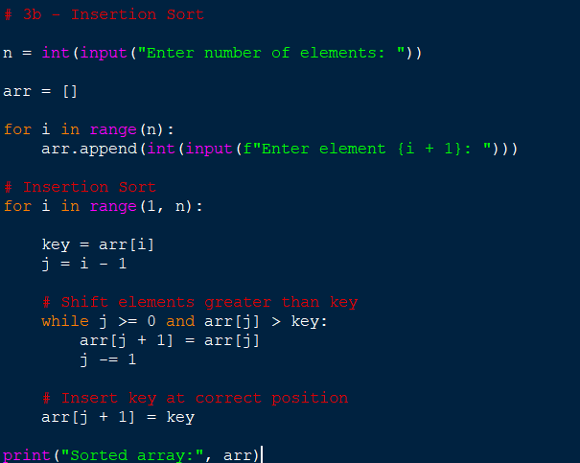
Output:
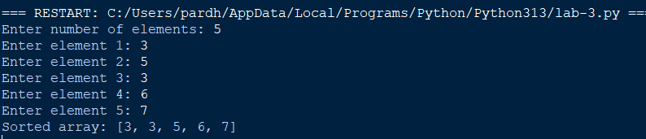

Explanation:
• Took the number of elements from the user.
• Used a loop to input every element.
• Started sorting from index 1.
• Stored the current element in key.
• Compared key with the elements before it.
• Shifted larger elements one position to the right.
• Inserted key into its correct position.
• Repeated until the array was sorted.

Error Table:
S.No. | Errors Observed | Rectification
1) | Starting the outer loop from 0, unnecessarily processing the first element. | Start the loop from 1 because the first element is already considered sorted.
2) | Forgetting to store the current element in key. | Use key = arr[i] before shifting elements.
3) | Forgetting j -= 1, causing the while loop to run indefinitely. | Decrease j by using j -= 1 after shifting an element.
4) | Placing the key at arr[j] instead of arr[j + 1]. | Insert the key using arr[j + 1] = key.
5) | Incorrect condition in the while loop. | Use j >= 0 and arr[j] > key to shift larger elements.

3C) Aim: Write a python program to sort an array using Bubble sort and take the elements as input from user
Program:
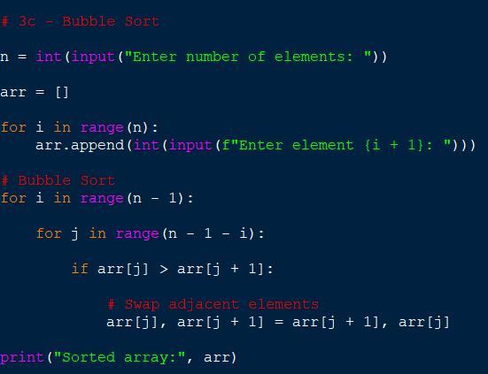
Output:
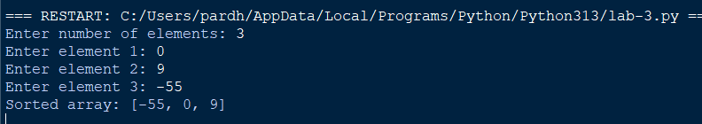

Explanation:
• Took the number of elements.
• Input each element using a loop.
• Compared two adjacent elements.
• If the left element was greater, we swapped them.
• After every pass, the largest remaining element moved to the end.
• Reduced the comparison range after every pass.
• Repeated until the array became sorted.

Error Table:
S.No. | Errors Observed | Rectification
1) | Comparing non-adjacent elements instead of neighboring elements. | Compare arr[j] with arr[j + 1].
2) | Using an incorrect inner loop range. | Use range(n - 1 - i) so that already sorted elements are not checked
3) | Forgetting to swap elements when they are in the wrong order. | Use arr[j], arr[j + 1] = arr[j + 1], arr[j].
4) | Using < instead of > for ascending order. | Use if arr[j] > arr[j + 1] for ascending sorting.
5) | Using an incorrect outer loop range. | Use range(n - 1) to perform the required passes.
6) | Entering non-numeric values as array elements. | Enter valid integer values using int(input()).

3A) Aim: Write a python program to sort an array using Merge sort and take the elements as input from user; 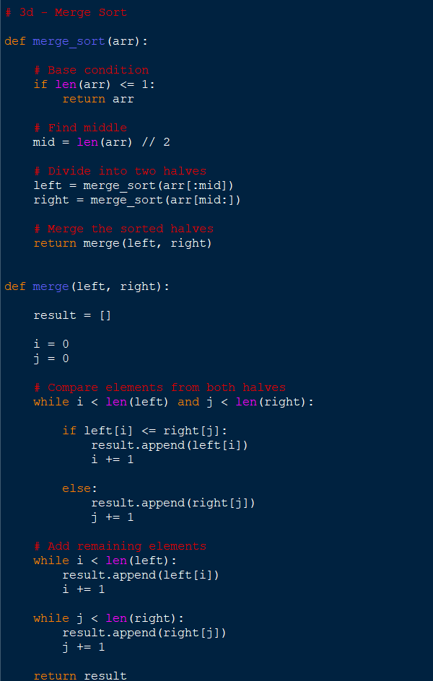

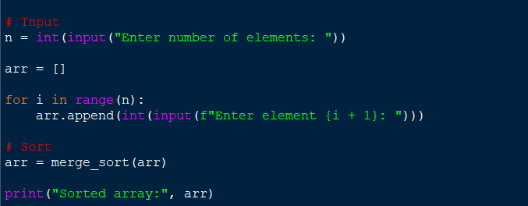

Output:
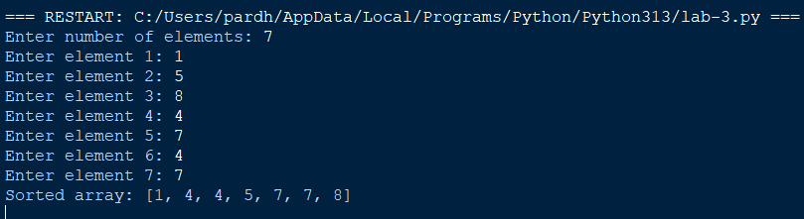

Explanation:
• Took the number of elements from the user.
• Used a loop to input the array.
• Used recursion to divide the array.
• Divided the array into two halves.
• Continued dividing until each part contained one element.
• Used the merge() function to combine the smaller arrays.
• Compared elements from the left and right halves.
• Added the smaller element to result.
• Added remaining elements.
• Returned the sorted array.

S.No. | Errors Observed | Rectification
1) | Missing base case causing infinite recursion. | Include if len(arr) <= 1: return arr to stop recursion.
2) | Incorrect calculation of the middle position. | Use mid = len(arr) // 2 to divide the array correctly.
3) | Incorrectly dividing the array into left and right parts. | Use arr[:mid] for the left half and arr[mid:] for the right half.
4) | Forgetting to increment i or j while merging. | Increment the corresponding index after adding an element to result.
5) | Forgetting to add the remaining elements from either half. | Add the remaining elements using result.extend(left[i:]) and result.extend(right[j:]).
6) | Forgetting to return the merged result. | Use return result at the end of the merge() function.
7) | Incorrect indentation in recursive functions. | Maintain proper indentation for all function statements, loops, and conditions.
3A) Aim: Write a python program to sort an array using Quick sort and take the elements as input from user;
Program:
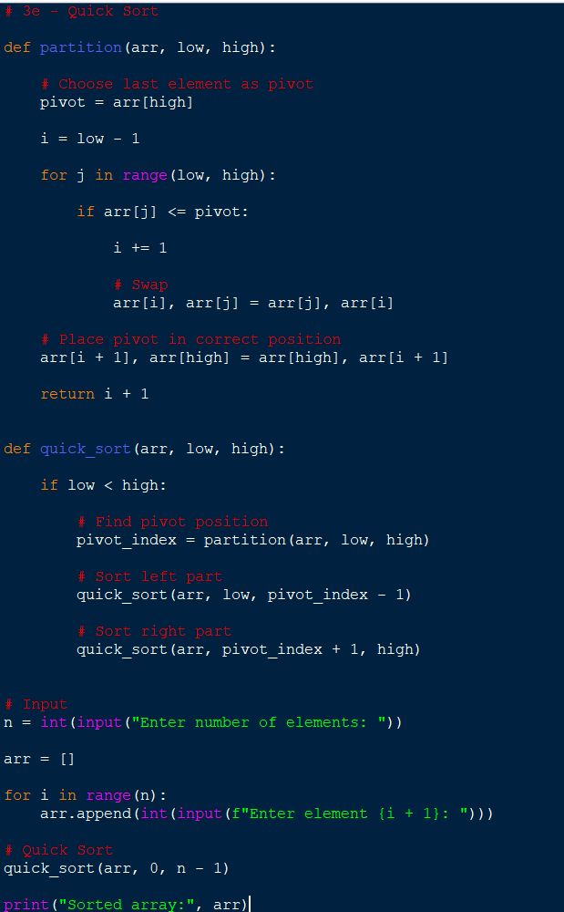
Output:
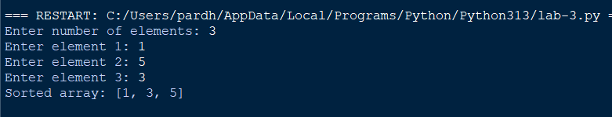

Explanation:
• Took the number of elements.
• Used a loop to input every element.
• Selected the last element as the pivot.
• Compared every element with the pivot.
• Elements smaller than or equal to the pivot were moved to the left.
• Elements greater than the pivot remained on the right.
• Placed the pivot in its correct position.
• Recursively sorted the left and right portions.
• Continued until the entire array was sorted.

S.No. | Errors Observed | Rectification
1) | Missing base condition causing infinite recursion. | Use if low < high: to continue recursion only when elements remain to be sorted.
2) | Incorrectly selecting or accessing the pivot element. | Select the last element using pivot = arr[high].
3) | Forgetting to return the pivot index from the partition function. | Use return i + 1 after placing the pivot.
4) | Incorrect recursive boundaries causing the pivot to be processed again. | Use quick_sort(arr, low, pivot_index - 1) and quick_sort(arr, pivot_index + 1, high).
5) | Incorrect initial function call. | Call quick_sort(arr, 0, n - 1) to sort the complete array.
6) | Incorrect partition condition resulting in improper ordering. | Use if arr[j] <= pivot for ascending order.
7) | Forgetting to swap the pivot into its correct position. | Use arr[i + 1], arr[high] = arr[high], arr[i + 1].
8) | Incorrect indentation causing an IndentationError. | Maintain proper Python indentation inside functions, loops, and conditions.

WEEK – 4
4a. AIM: Write a python program to implement a single linked list which would perform the below operations, by taking an input from the user.
a. Create a linked list. b. Insert at beginning. c. Insert at end.
d. Insert at a specific index. e. Delete by value. f. Delete 1st node.
g. Delete last node. h. Count no. of nodes i. Display.
j. Exit.
PROGRAM:
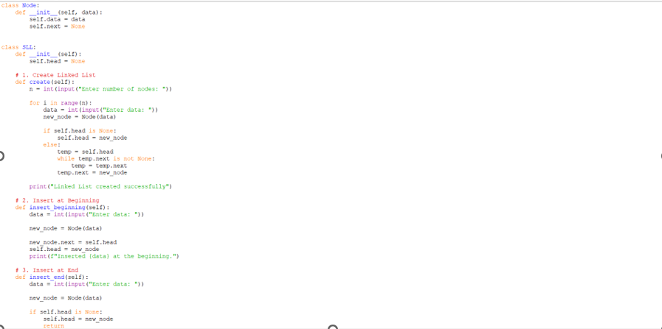
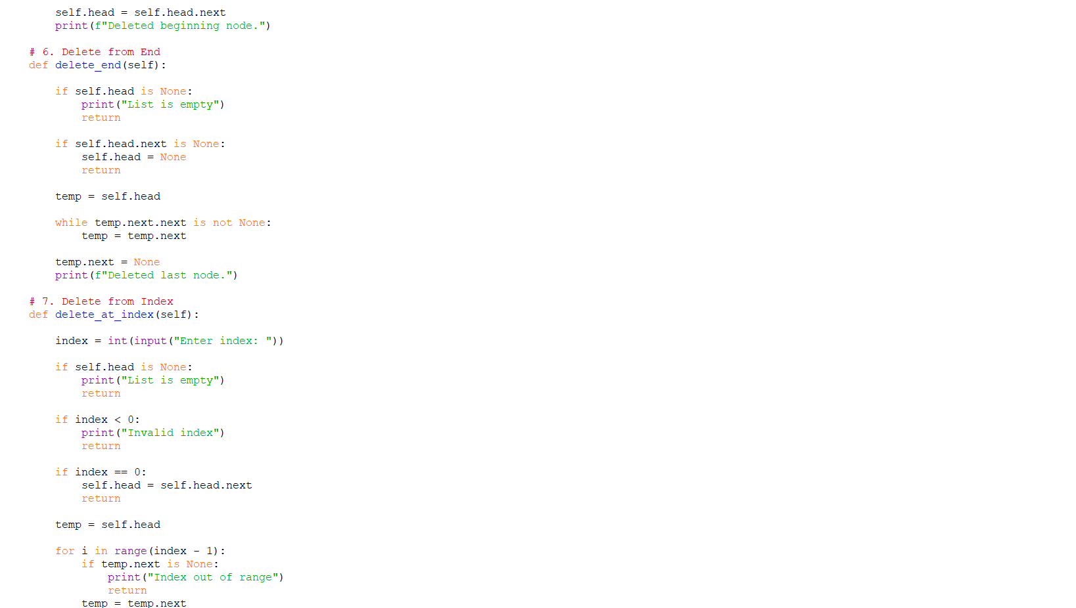
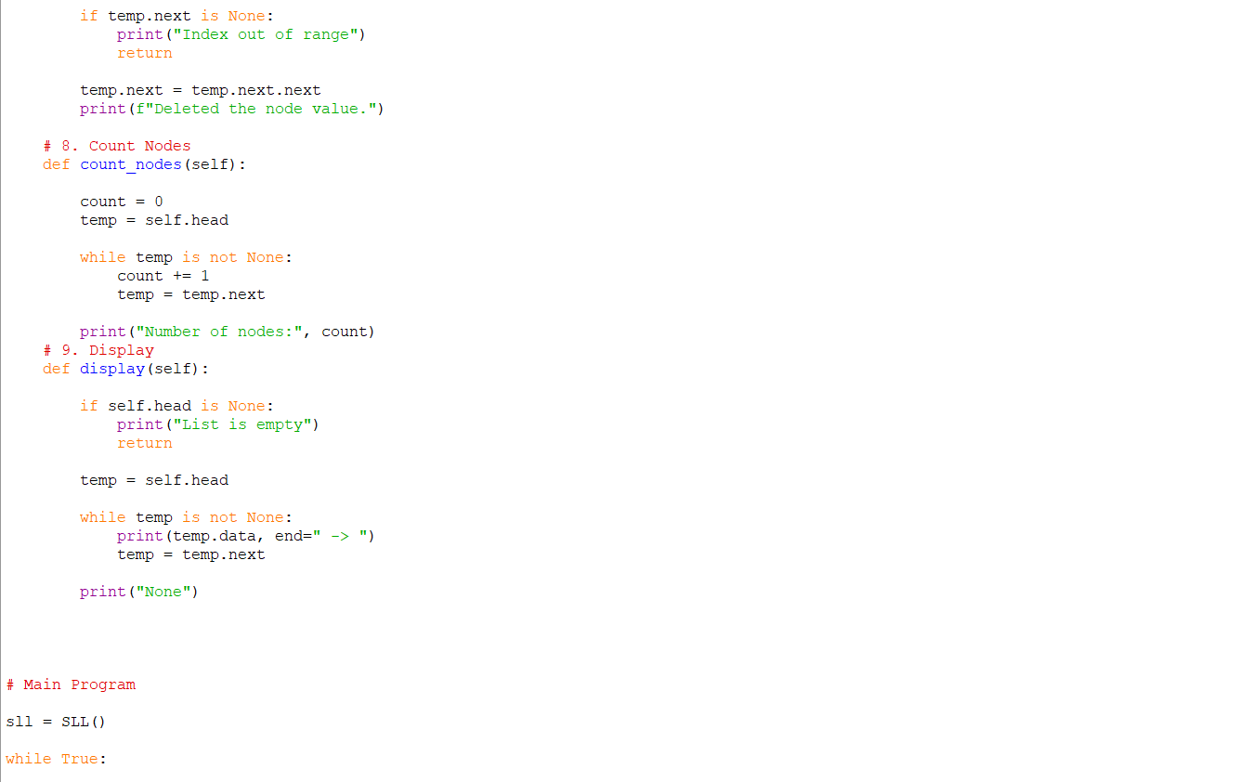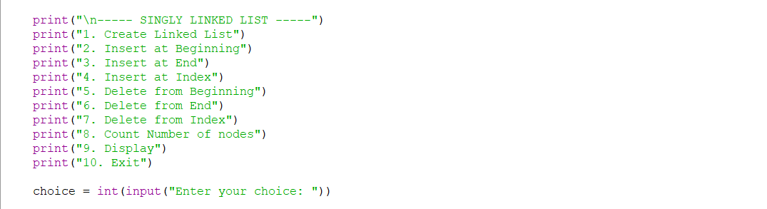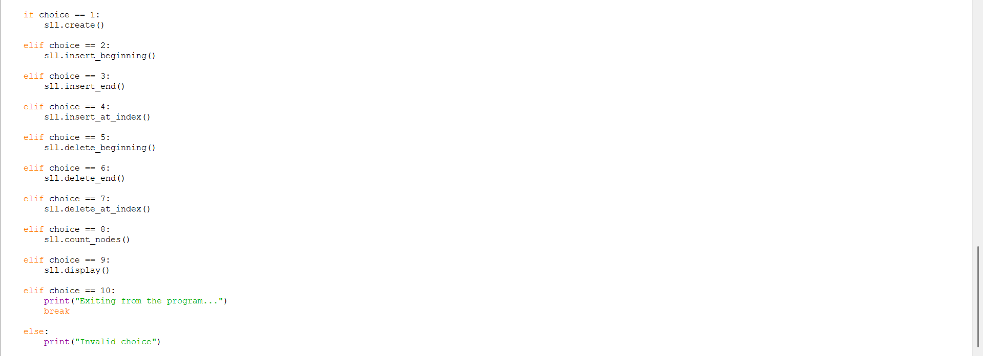
OUTPUT:
Positive Case;
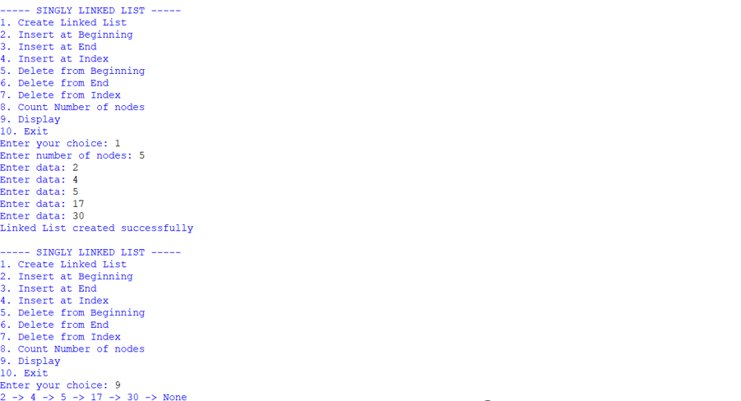
Negative Case;
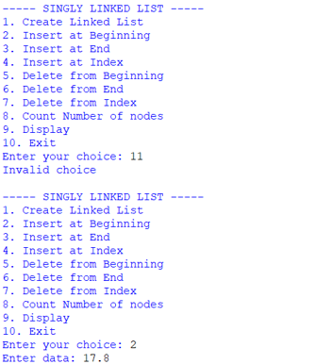
EXPLANATION:
🔹 Class Definitions
- Node class
  - Represents a single node in the linked list.
  - Each node has:
    - data → stores the value.
    - next → pointer to the next node (initially None).
- SLL class
  - Manages the linked list operations.
  - Has a head pointer (initially None) that points to the first node.
🔹 Operations in SLL
1. Create Linked List
- Asks user for number of nodes.
- For each node:
  - Creates a new Node.
  - If list is empty → new node becomes head.
  - Otherwise → traverses to the end and attaches the new node.
2. Insert at Beginning
- Creates a new node.
- Points its next to current head.
- Updates head to new node.
3. Insert at End
- Creates a new node.
- If list is empty → new node becomes head.
- Otherwise → traverses to last node and attaches new node.
4. Insert at Index
- Asks for index and data.
- If index = 0 → behaves like "insert at beginning".
- Otherwise → traverses to (index-1) node and inserts new node in between.
5. Delete from Beginning
- Moves head to head.next.
- Effectively removes the first node.
6. Delete from End
- If list empty → prints "List is empty".
- If only one node → sets head = None.
- Otherwise → traverses to second-last node and sets its next = None.
7. Delete from Index
- Asks for index.
- If index = 0 → removes head.
- Otherwise → traverses to (index-1) node and skips the next node.
8. Count Nodes
- Traverses through list.
- Counts nodes until None.
9. Display
- Traverses from head to end.
- Prints each node’s data in data -> data -> None format.
🔹 Main Program
- Runs an infinite loop with a menu:
  - Options 1–9 → perform linked list operations.
  - Option 10 → exits program.
- Uses if-elif to call respective methods.

ERROR TABLE:

S.NO | Error Obtained | Rectification
1. | Index out of range  When inserting/deleting at an index greater than the number of nodes. | Traverse carefully;  if temp becomes None before reaching index, print "Index out of range" and stop.
2. | Logical error in insertion  if index is negative. | Validate index: if index < 0: print ("Invalid index").
3. | Wrong output format  In display (missing None at end). | After traversal, always print "None" to mark end of list.
4. | Indentation Error  In the Count node part | It was rectified later,  By maintaining proper indentation.

4b. AIM: Write a python program to implement a double linked list which would perform the below operations, by taking an input from the user.
a. Create a linked list. b. Insert at beginning. c. Insert at end.
d. Insert at a specific index. e. Delete by value. f. Delete 1st node.
g. Delete last node. h. Count no. of nodes i. Display.
j. Exit.
PROGRAM:
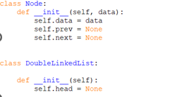
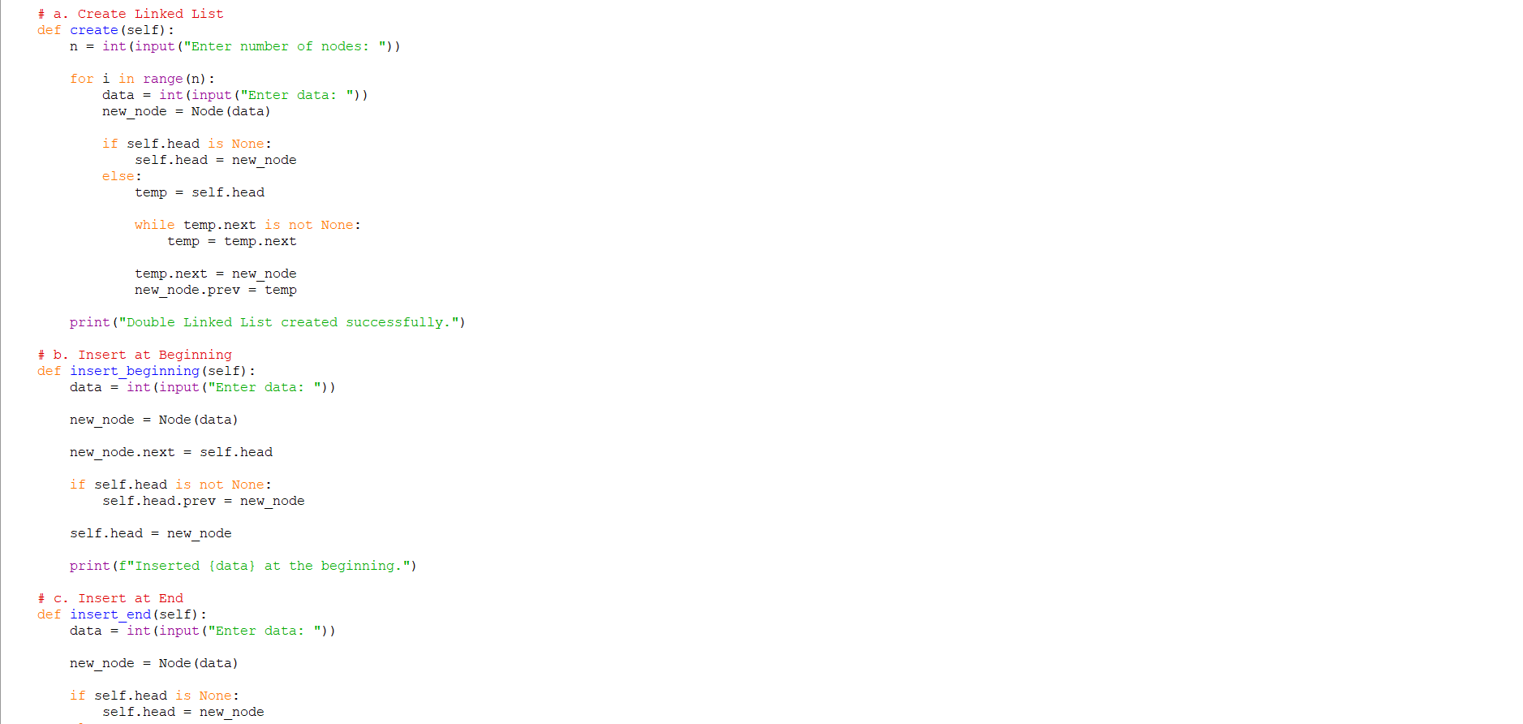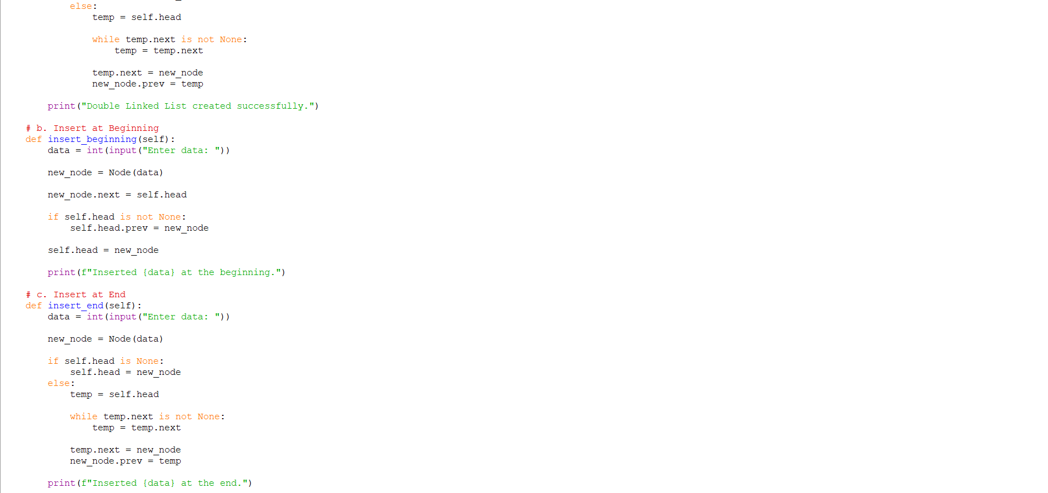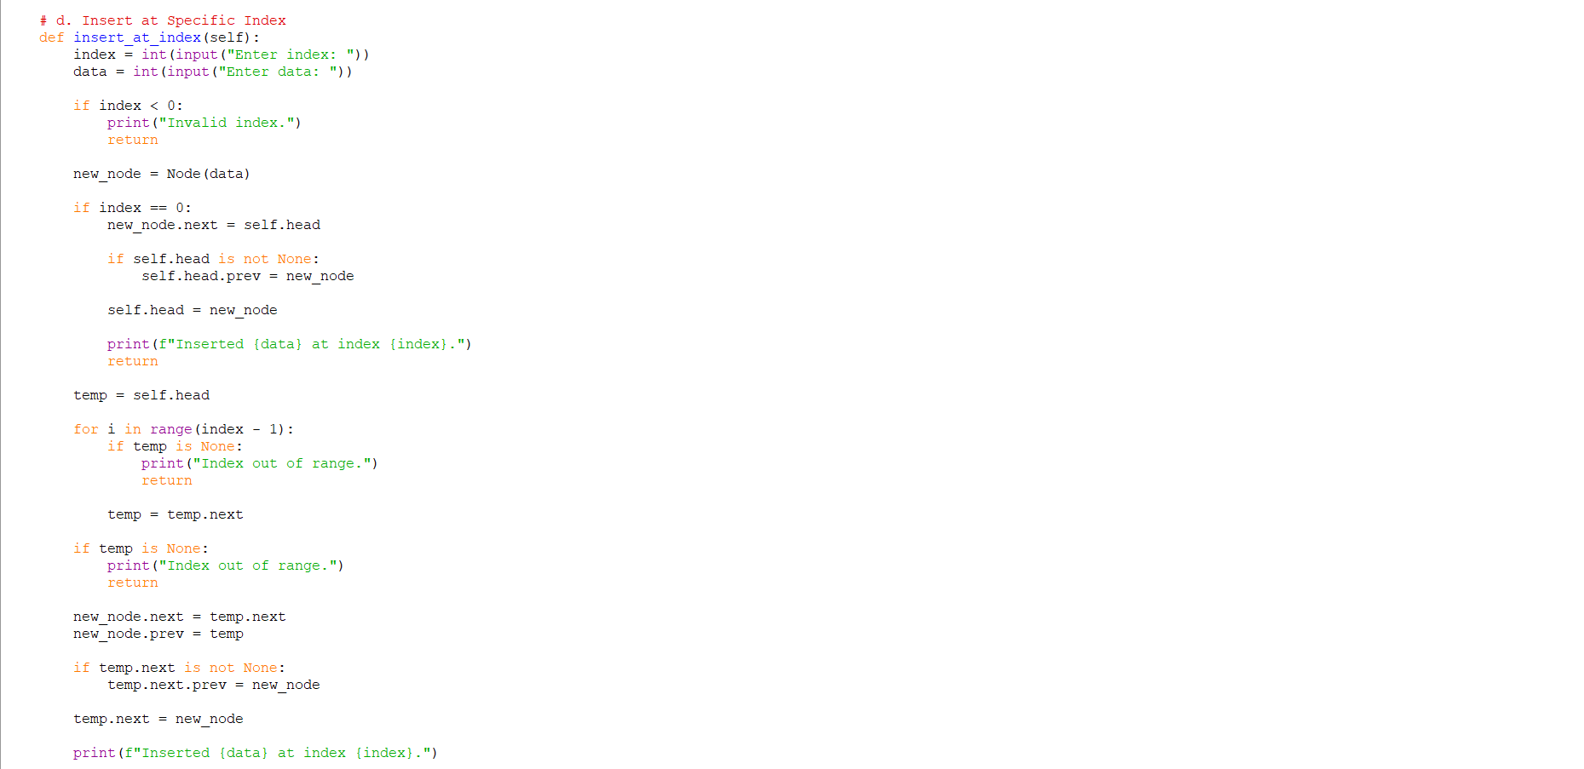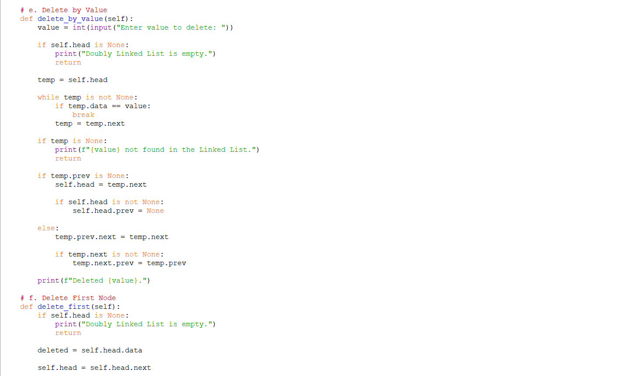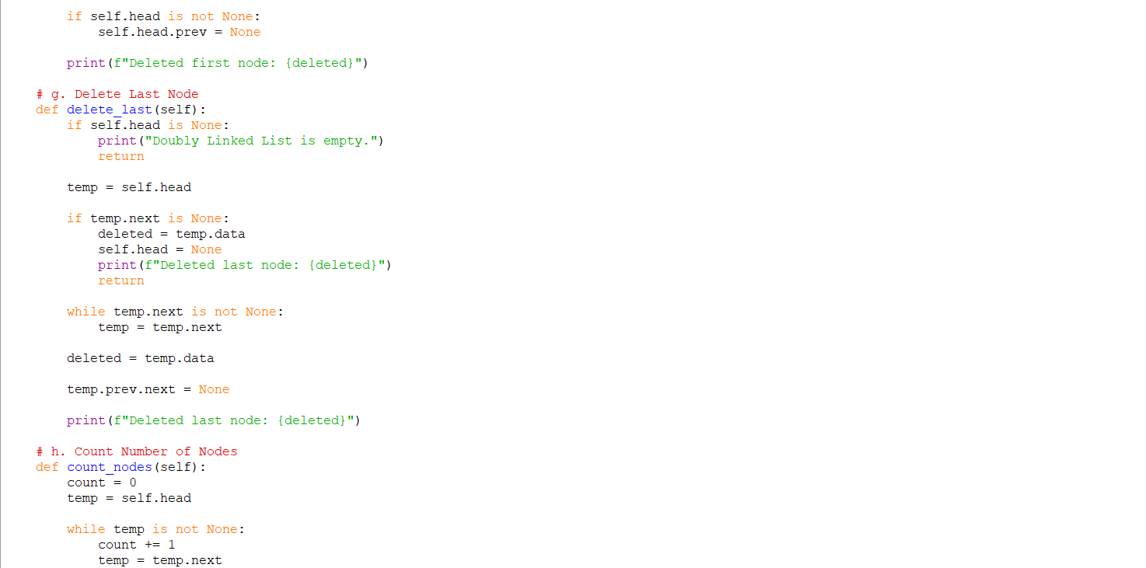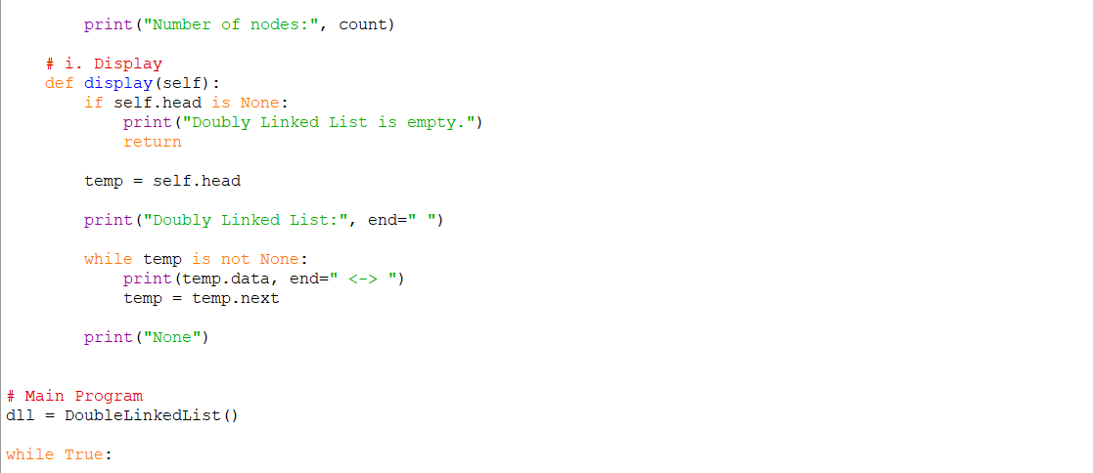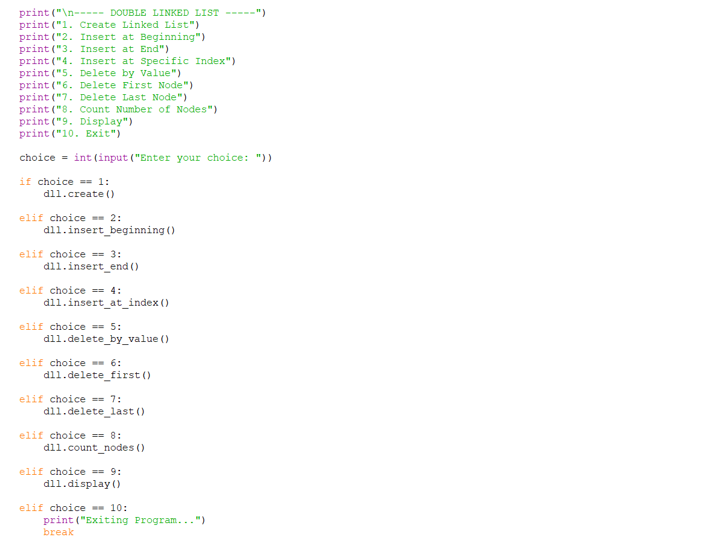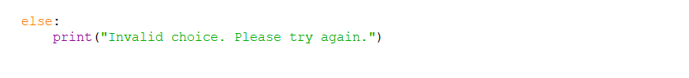
OUTPUT:
Positive Case;
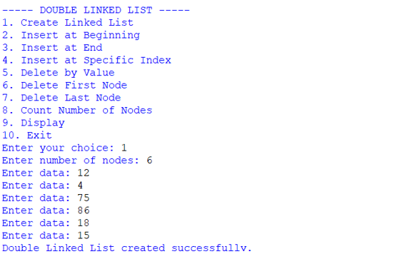
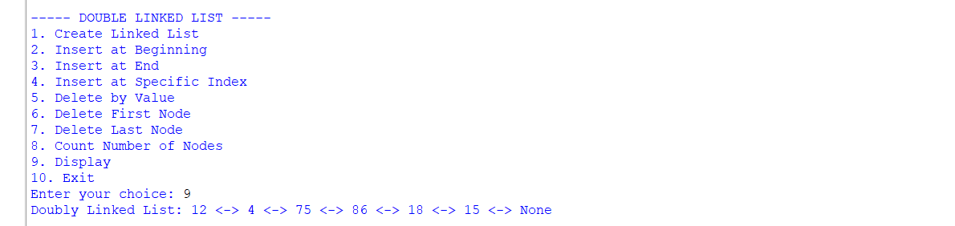 Negative Case;
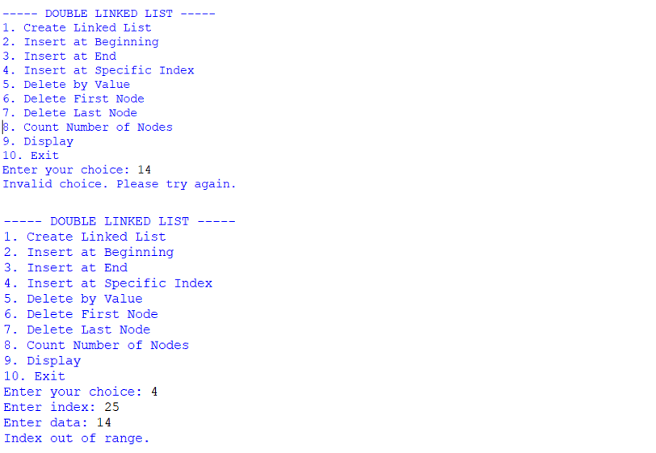
EXPLANATION:
1. Node Class
- Each node stores:
  - data: the actual value.
  - prev: pointer to the previous node.
  - next: pointer to the next node.
- This structure allows traversal in both directions (forward and backward).
2. Double Linked List Class
This class manages the linked list. It starts with self.head = None (empty list). It provides several operations:
a. Create Linked List
- User specifies how many nodes to create.
- Each new node is linked at the end.
- prev pointer connects the new node to the previous one.
b. Insert at Beginning
- A new node is created.
- Its next points to the current head.
- The old head’s prev points back to the new node.
- The new node becomes the head.
c. Insert at End
- Traverse to the last node.
- Attach the new node at the end.
- Update prev of the new node to point to the last node.
d. Insert at Specific Index
- Traverse until the given index.
- Insert the new node between two nodes.
- Adjust both next and prev pointers to maintain the chain.
e. Delete by Value
- Search for the node with the given value.
- If found:
  - If it’s the head, move head to the next node.
  - Otherwise, adjust prev.next and next.prev to bypass the node.
- This removes the node from the chain.
f. Delete First Node
- Move head to the second node.
- Set its prev to None.
g. Delete Last Node
- Traverse to the last node.
- Remove it by setting its previous node’s next to None.
h. Count Nodes
- Traverse the list, incrementing a counter.
- Prints the total number of nodes.
i. Display
- Traverse from head to end.
- Print each node’s data in the format: data <-> data <-> ... None
3. Main Program (Menu-Driven)
- Runs an infinite loop with options:
  - Create Linked List
  - Insert at Beginning
  - Insert at End
  - Insert at Specific Index
  - Delete by Value
  - Delete First Node
  - Delete Last Node
  - Count Nodes
  - Display
10.Exit
- Based on user choice, the corresponding method is executed.

ERROR TABLE:

S.NO | Error Obtained | Rectification
1. | Invalid index entered (negative or too large). | Add a check: if index < 0 → print "Invalid index"; if traversal reaches None before index → print "Index out of range".
2. | Deleting from an empty list. | Before deletion, check if self.head is None: → print "Doubly Linked List is empty."
3. | Value not found during deletion by value. | Traverse list; if node not found → print "value not found in the Linked List."
4. | Insertion at index when list is empty but index > 0. | Handle separately: if self.head is None and index! = 0 → print "Index out of range."

4c. AIM: Write a python program to implement a circular linked list which would perform the below operations, by taking an input from the user.
a. Create a linked list. b. Insert at beginning. c. Insert at end.
d. Insert at a specific index. e. Delete by value. f. Delete 1st node.
g. Delete last node. h. Count no. of nodes i. Display.
j. Display head and tail. k. Print data from tail to head. l. Exit.
PROGRAM:
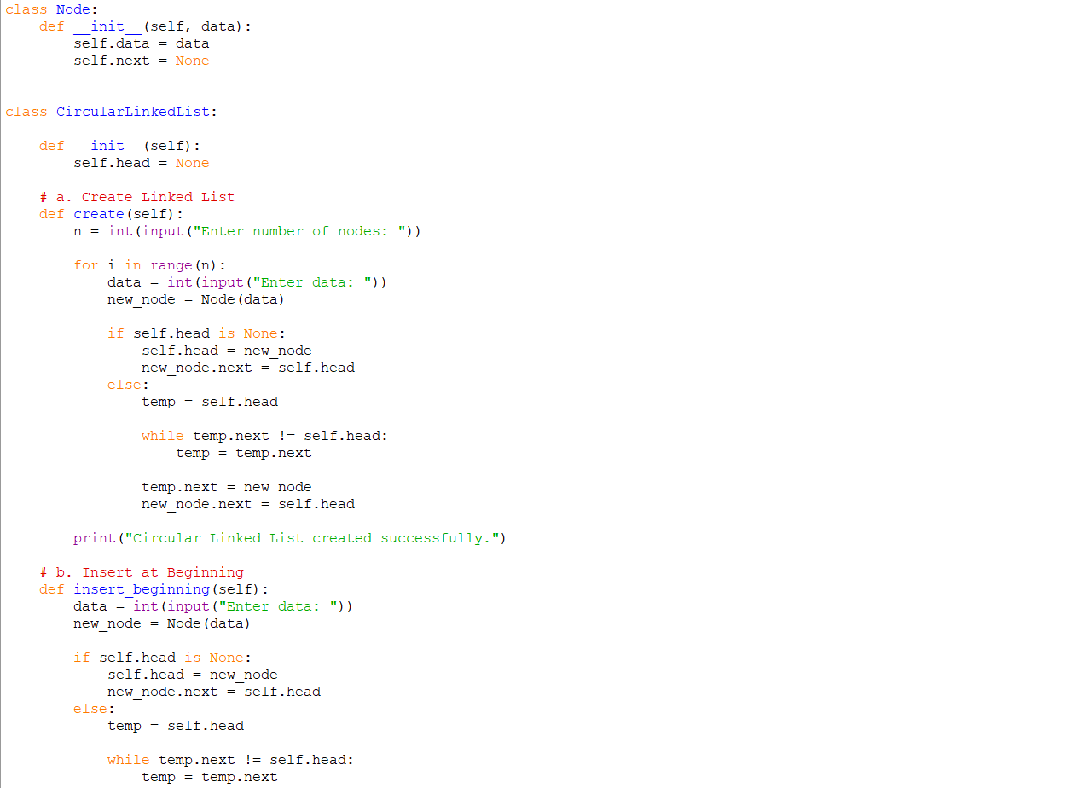
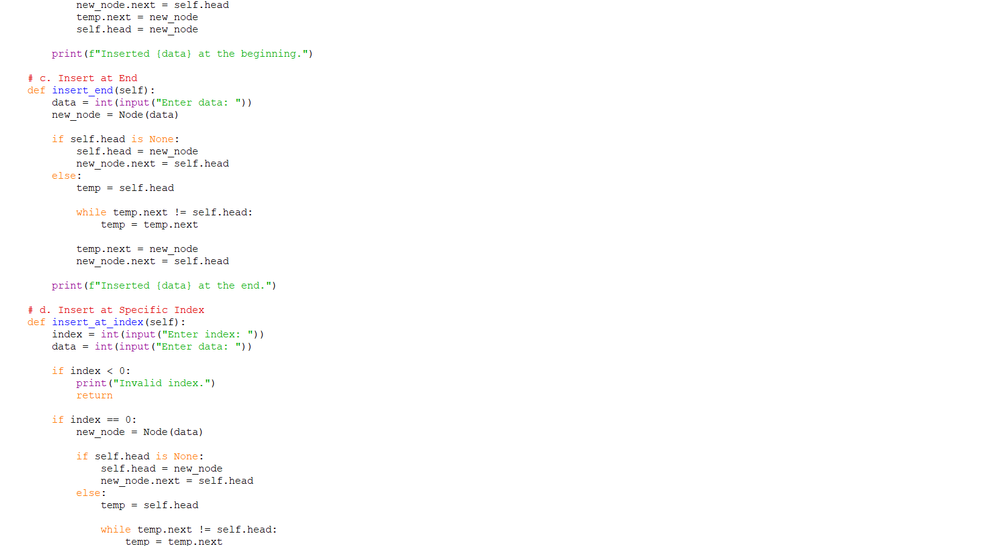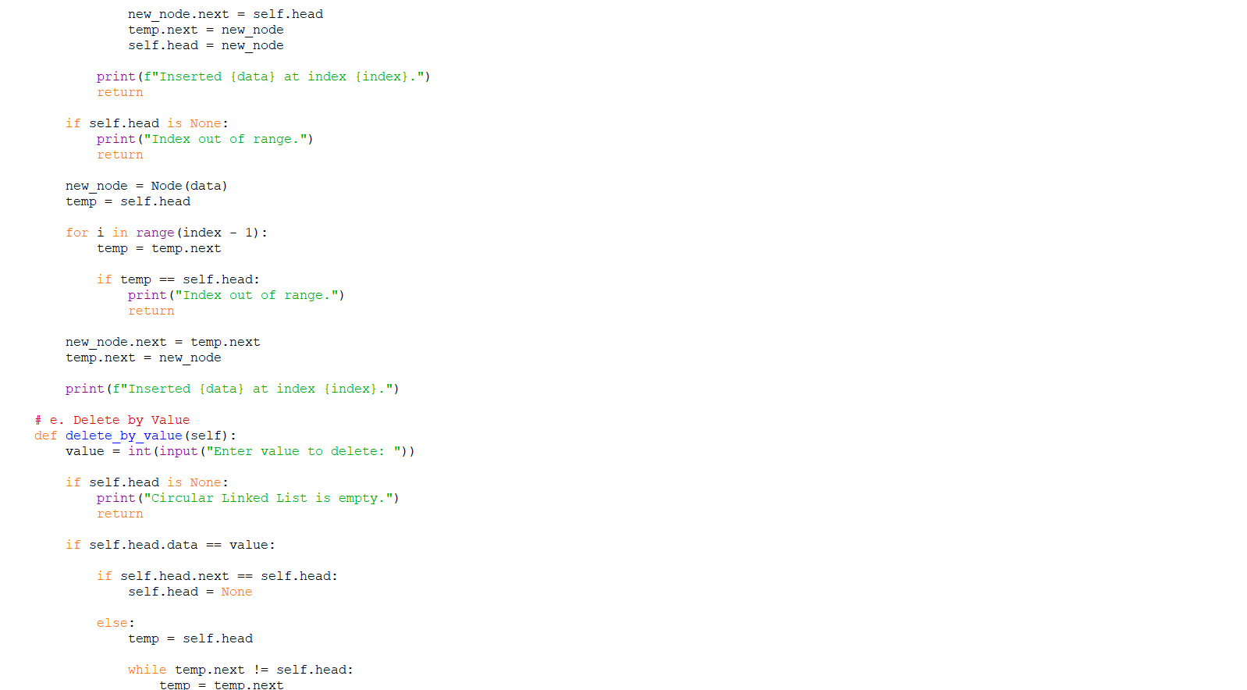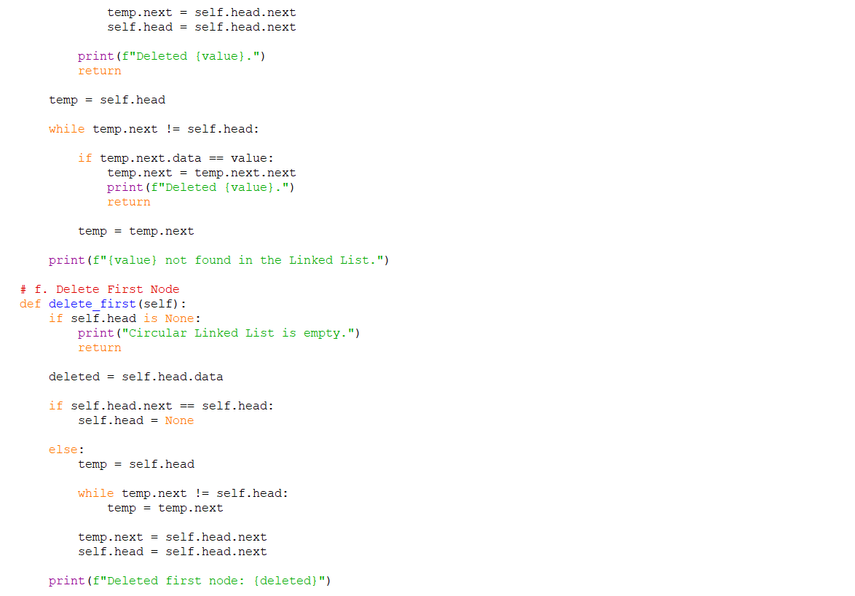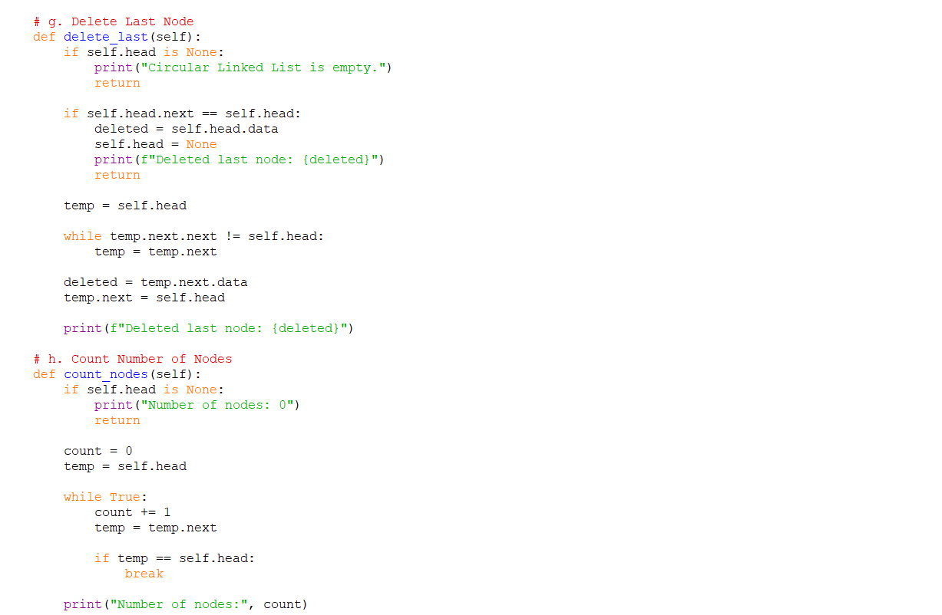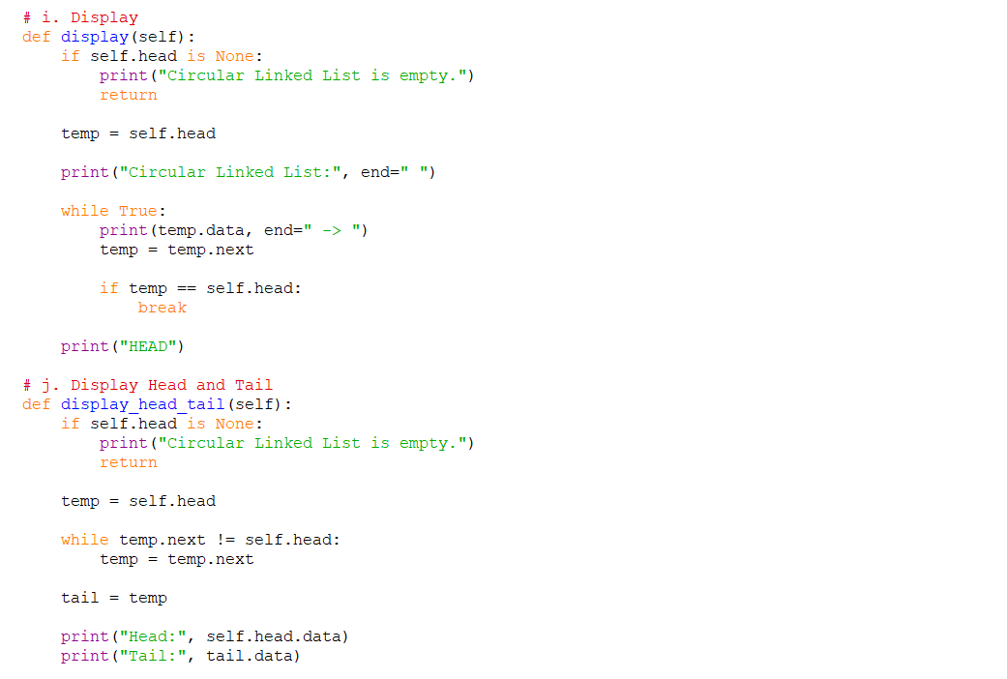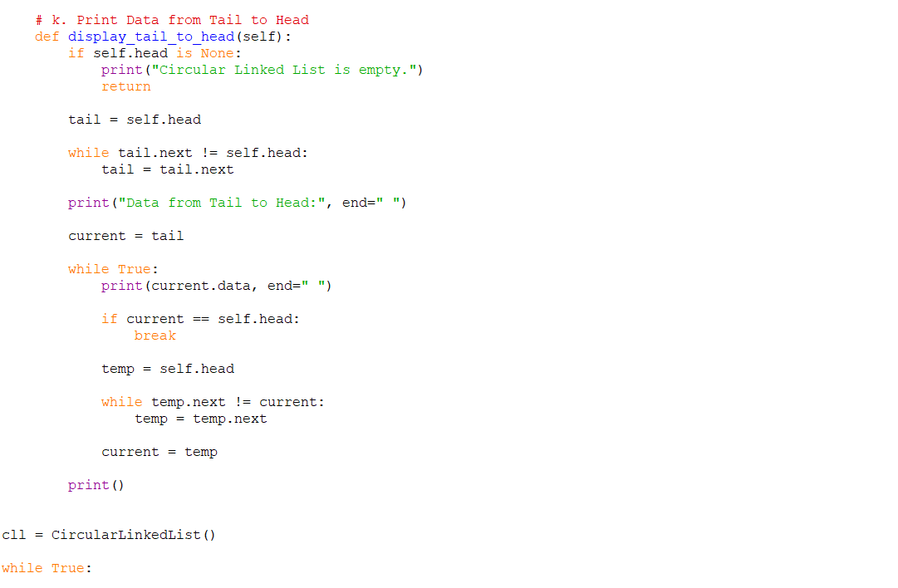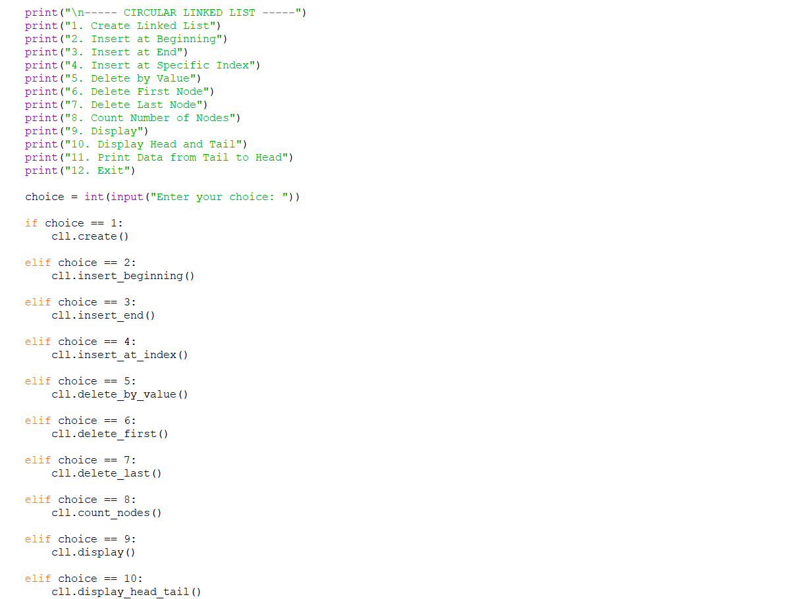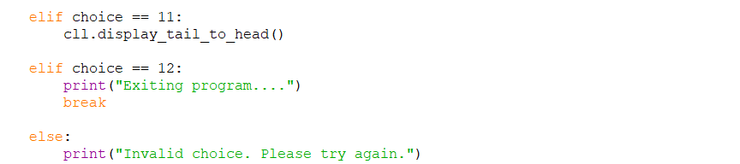

OUTPUT:
Positive Case;
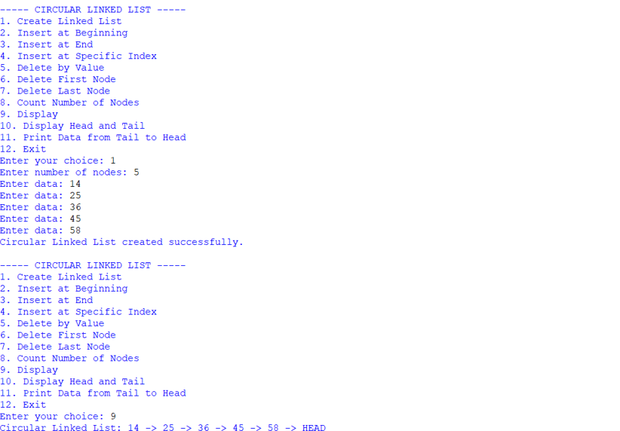
Negative Case;
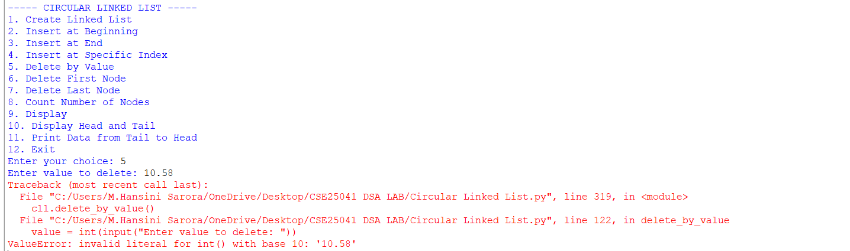

EXPLANATION:
1. Node Class
- Each node stores:
  - data: the value.
  - next: pointer to the next node.
- In a circular linked list, the last node’s next points back to the head, forming a circle.
2. Circular Linked List Class
This class manages the linked list. It starts with self.head = None (empty list). It provides several operations:
a. Create Linked List
- User specifies number of nodes.
- Each new node is linked at the end.
- The last node’s next points back to the head, ensuring circularity.

b. Insert at Beginning
- A new node is created.
- It becomes the new head.
- The last node’s next is updated to point to this new head.
c. Insert at End
- Traverse to the last node.
- Attach the new node after it.
- New node’s next points back to head.
d. Insert at Specific Index
- If index = 0 → same as inserting at beginning.
- Otherwise, traverse to the given position.
- Insert the new node between two nodes.
- Maintain circularity by adjusting next pointers.
e. Delete by Value
- Search for the node with the given value.
- If it’s the head:
- If only one node exists → set head to None.
Otherwise, adjust last node’s next to point to new head.
- If it’s in the middle → bypass the node by linking previous node’s next to the next node.
f. Delete First Node
- If only one node → set head to None.
- Otherwise, move head to the second node and update last node’s next.

g. Delete Last Node
- Traverse to the second-last node.
- Make its next point to head.
- Removes the last node.
h. Count Nodes
- Traverse until you return to head.
- Count nodes during traversal.
i. Display
- Print nodes starting from head.
- Stop when traversal returns to head.
- Shows circularity by ending with "HEAD".
j. Display Head and Tail
- Head = first node.
- Tail = last node (whose next points to head).
- Prints both values.
k. Print Data from Tail to Head
- Find tail.
- Traverse backward by repeatedly searching for the node whose next points to the current node.
- Prints values in reverse order until reaching head.
3. Main Program (Menu-Driven)
- Runs an infinite loop with give options.
- Based on user choice, the corresponding method is executed.

ERROR TABLE:

S.NO | Error Obtained | Rectification
1. | Display on empty list. | Add condition:  if self.head is None: → print "Circular Linked List is empty."
2. | Deleting from an empty list. | Before deletion, check if self.head is None: → print "Circular Linked List is empty."
3. |  | Ensure every insertion/deletion maintains circularity: last node’s next must always point to self.head.
  Infinite loop in traversal
  (if circularity broken).
4. | Reverse traversal  (Tail to Head) inefficient. | Current implementation repeatedly searches for predecessor. Rectify by using a doubly circular linked list if reverse traversal is frequent.

WEEK – 5
5. AIM: Write a python program to implement a stack using an Array, Linked list. Implement the stack operations such as push, pop, peak and also display the stack elements.
PROGRAM:

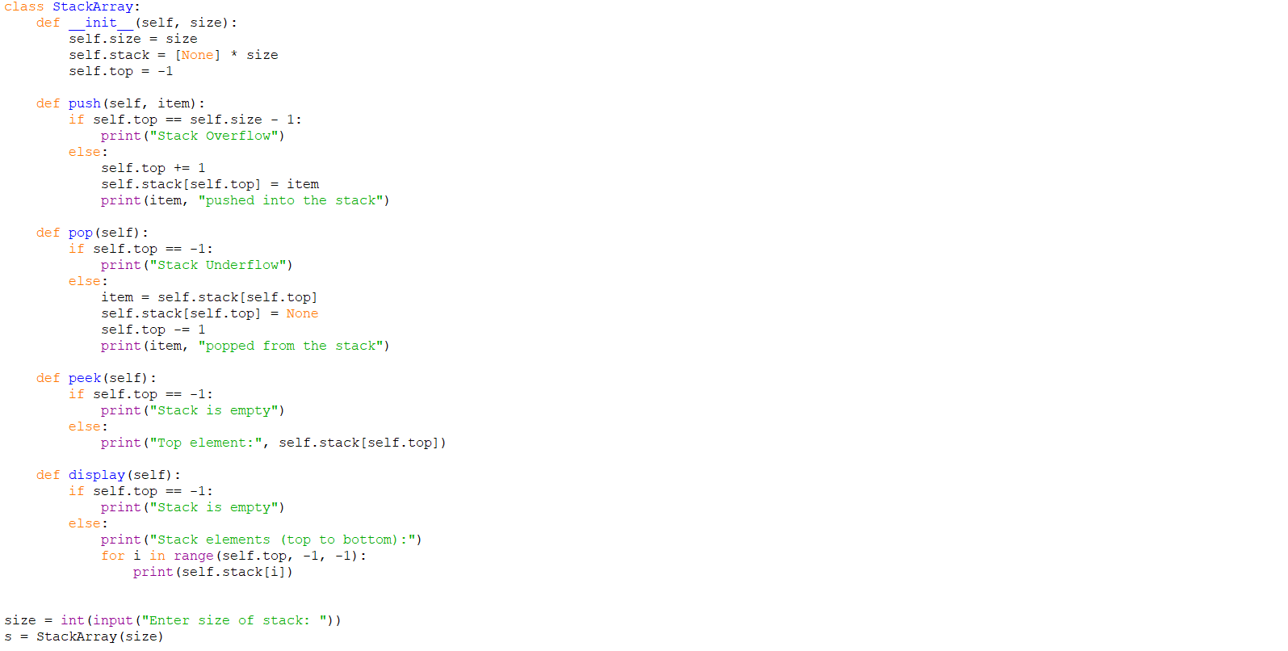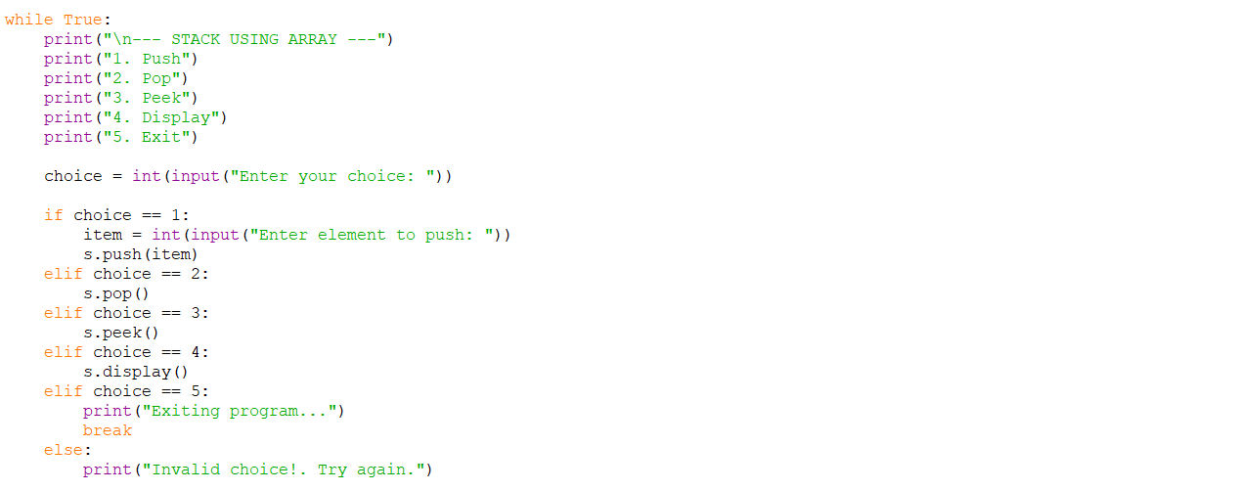 OUTPUT:
Positive Case;
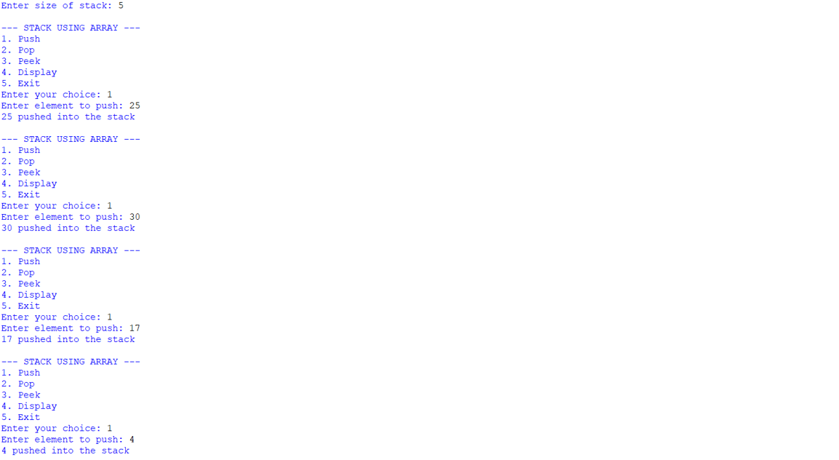
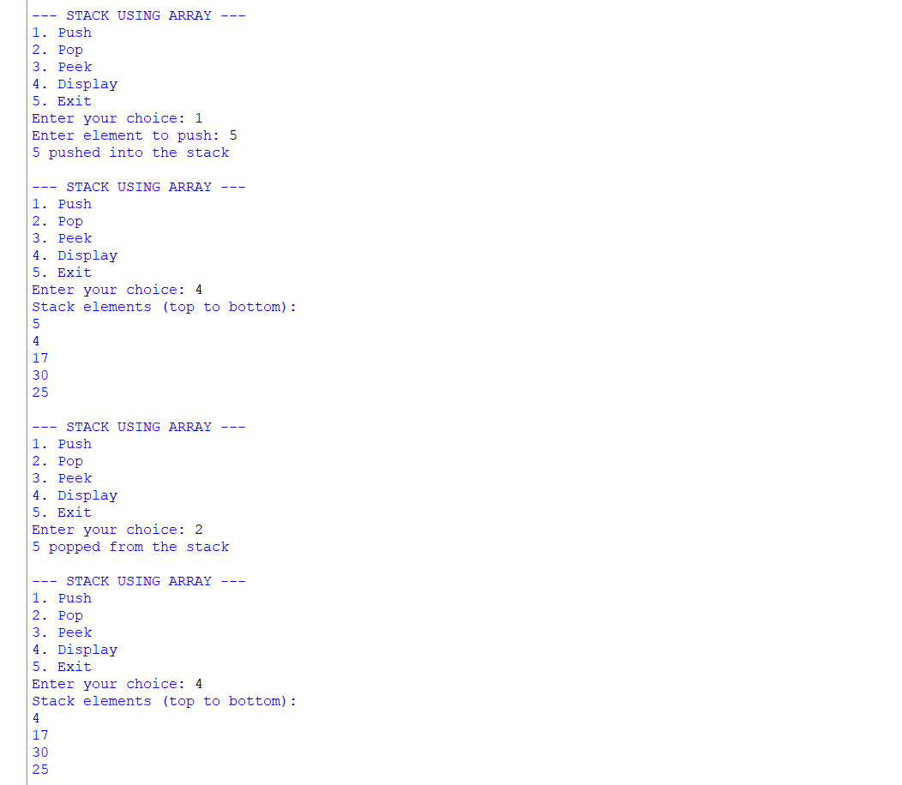 Negative Case;
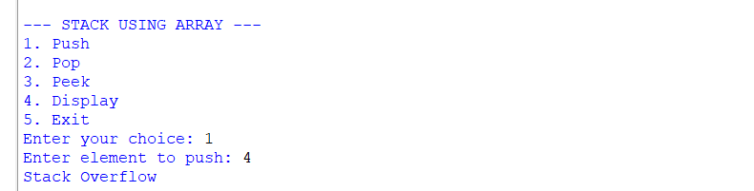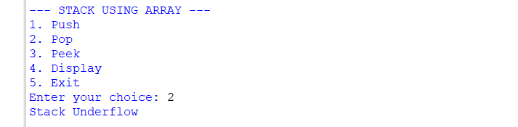

Stack Using Linked List;
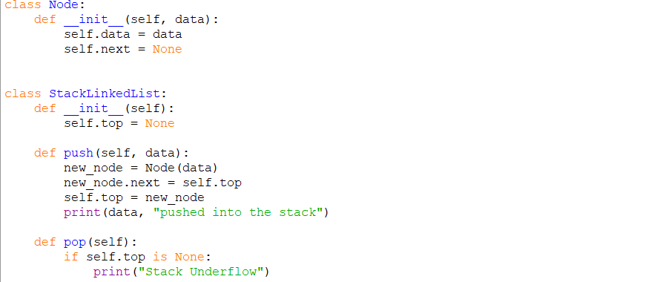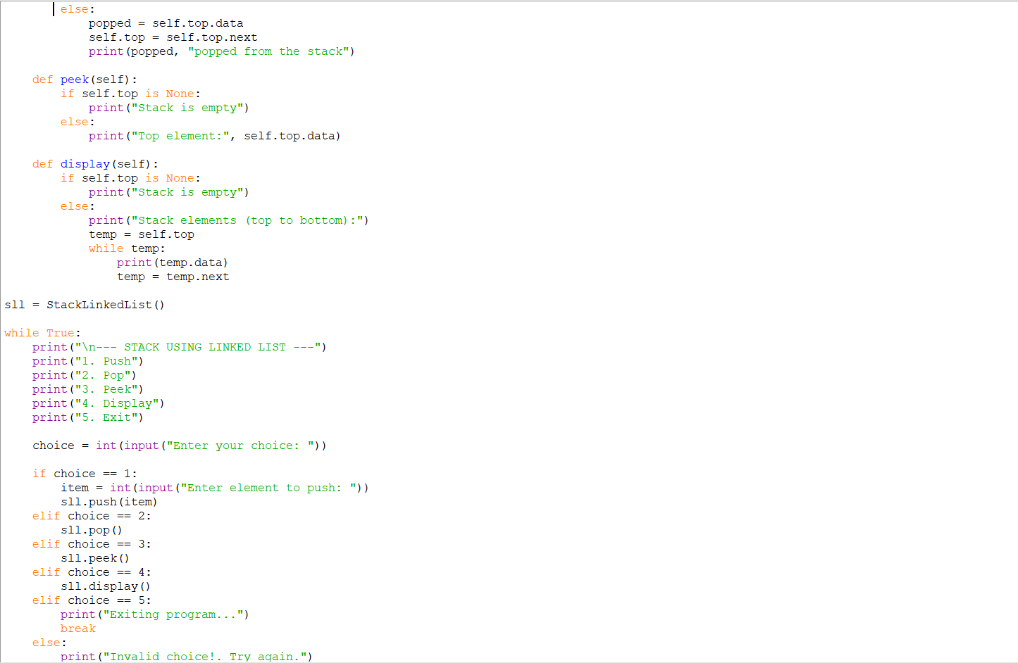 OUTPUT:
Positive Case;
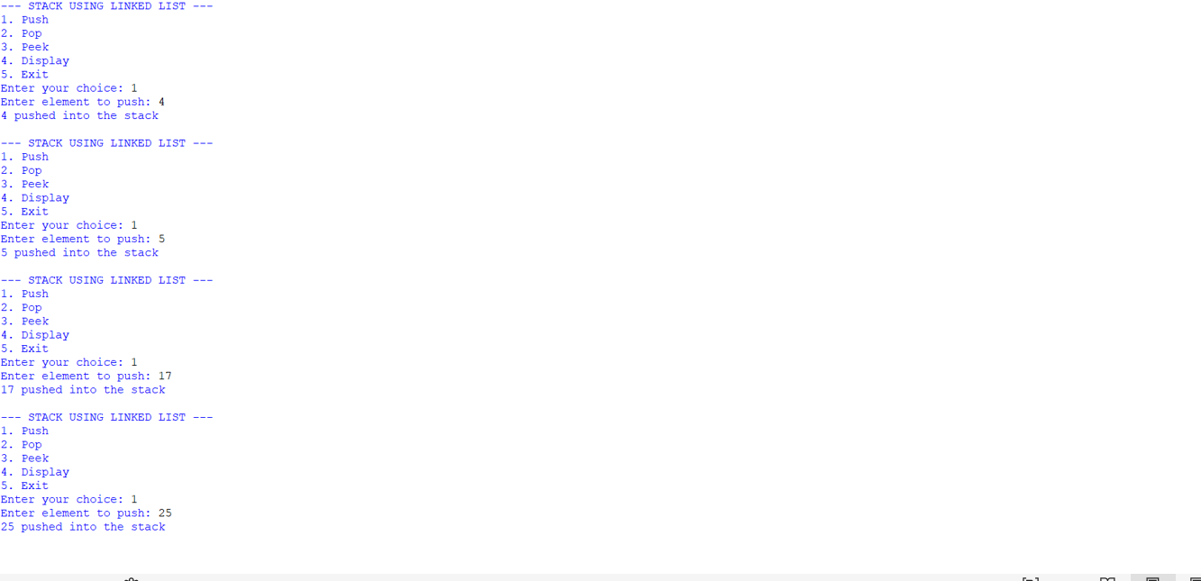
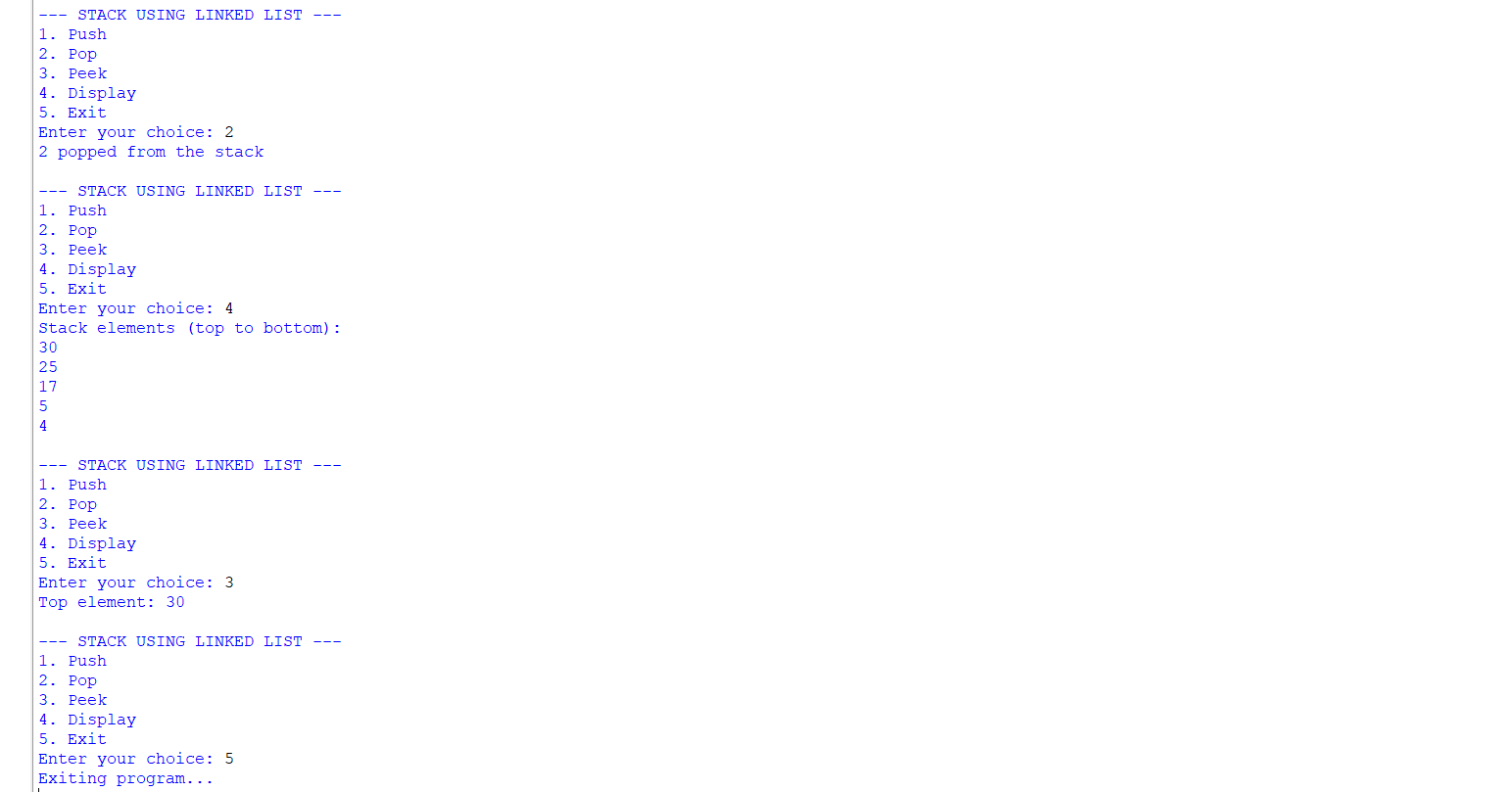 Negative Case;
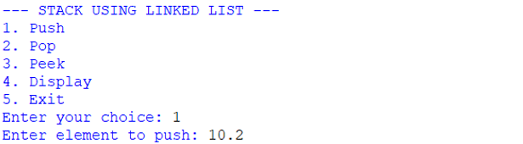
EXPLANATION:
🧩 Stack Using Array
Structure:
- Uses a Python list (self.stack) to store elements.
- self.top keeps track of the index of the last pushed element.
- self.size defines the maximum capacity.
Operations:
- Push
  - Check if top == size - 1 → Overflow.
  - Otherwise, increment top and insert the element at that position.
- Pop
  - Check if top == -1 → Underflow (empty stack).
  - Otherwise, remove the element at top, decrement top.
- Peek
  - Shows the element at top without removing it.
- Display
  - Prints elements from top down to 0 (top to bottom order).
🧩 Stack Using Linked List
Structure:
- Each element is a Node with:
  - data (value)
  - next (pointer to the next node).
- self.top points to the most recently pushed node.
Operations:
- Push
  - Create a new node.
  - Link its next to the current top.
  - Update top to this new node.
- Pop
  - If top is None → Underflow.
  - Otherwise, remove the node at top and update top to top.next.
- Peek
  - Shows the data at top.
- Display
  - Traverse from top downwards, printing each node’s data.

ERROR TABLE:
S.NO | Error Obtained | Rectification
1. | def _init_(self, size): | Python expects two underscores before and after init.
2. | Display on empty stack. | Add condition: if self.top is None: → print  "Stack is empty".
3. |  | Add a check: if self.top == self.size - 1: → print "Stack Overflow".
  Stack Overflow
  when pushing beyond the defined size
4. | Stack Underflow  when popping from empty stack | Add a check: if self.top is None: → print "Stack Underflow".
5. | Syntax error | Later it was rectified in the for loop of display section.

WEEK – 6
6. AIM: To implement Queue and its operations such as Enqueue, Dequeue, Peek, Display with a menu driven approach.
6a. Using Array, Linked list, Data structures.
6b. Circular Queue.
PROGRAM:
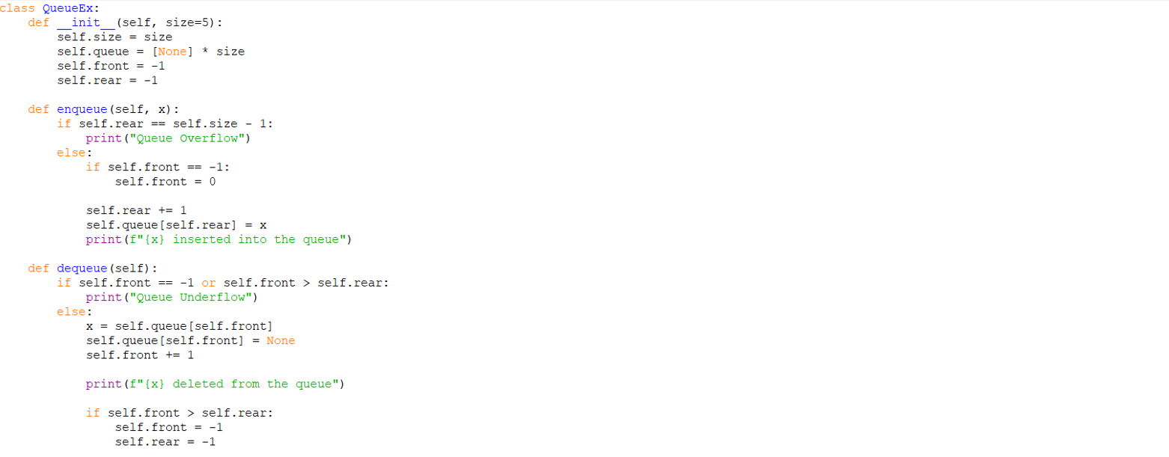
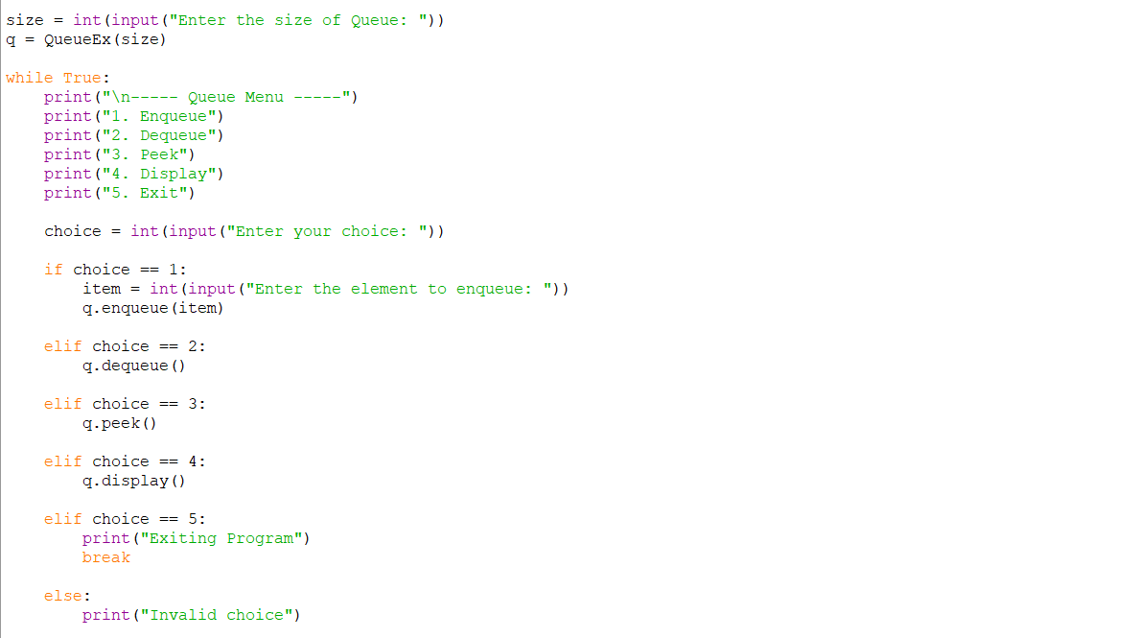
OUTPUT:
Positive Case;
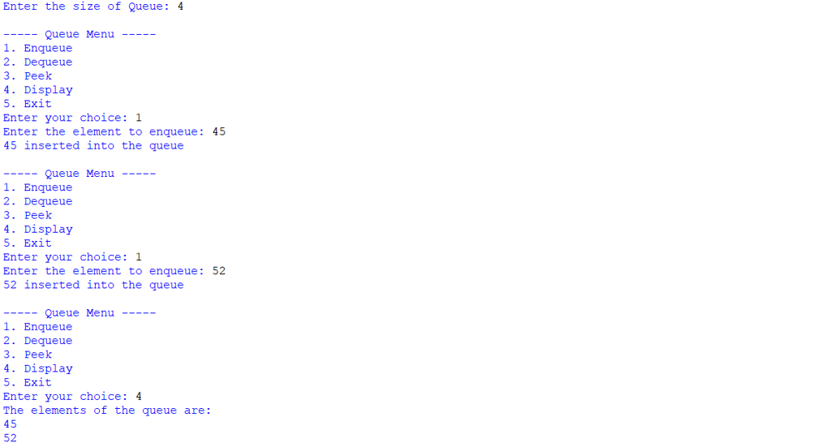
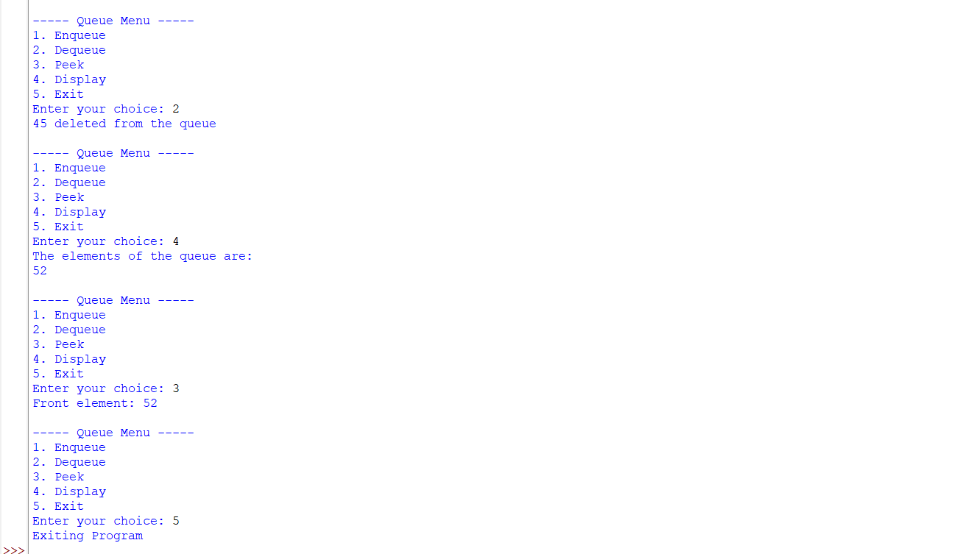
Negative Case;
Linked List.,
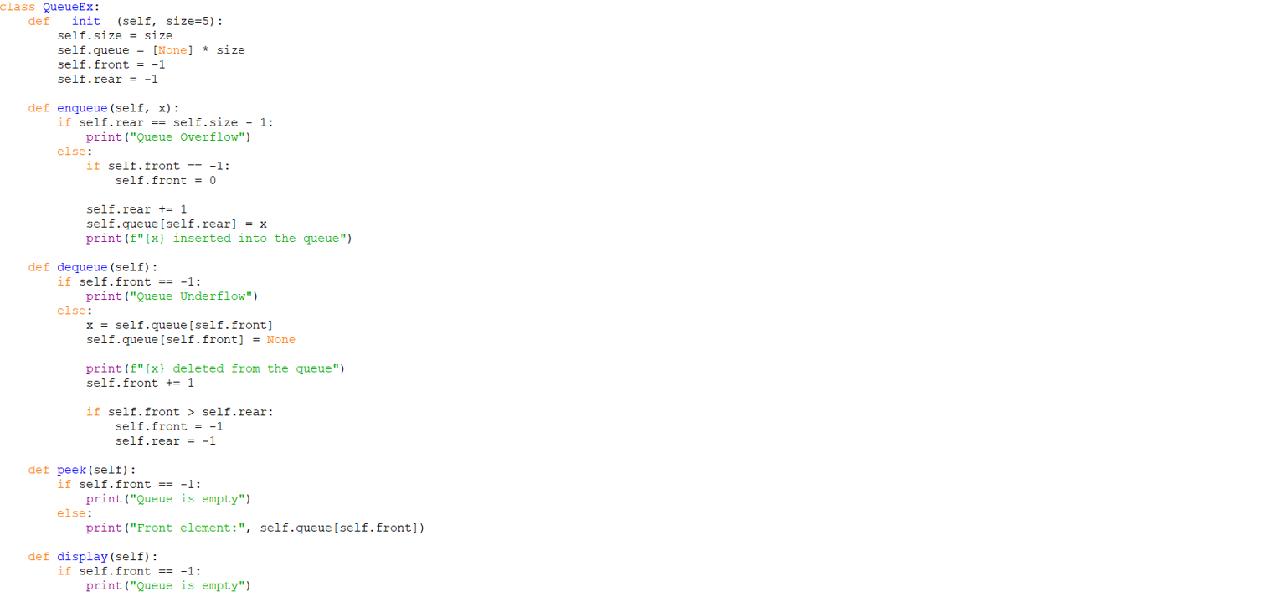
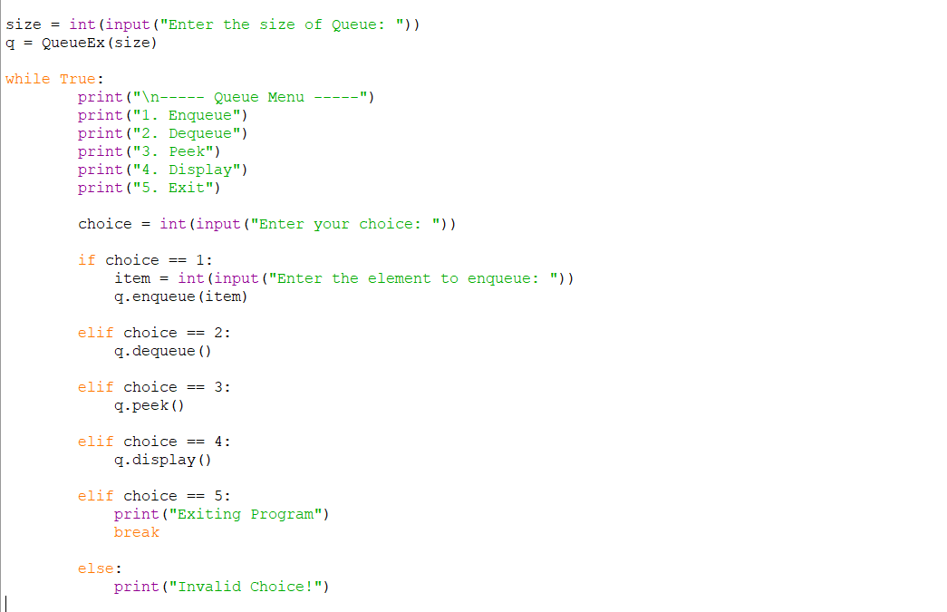
OUTPUT:
Positive Case;
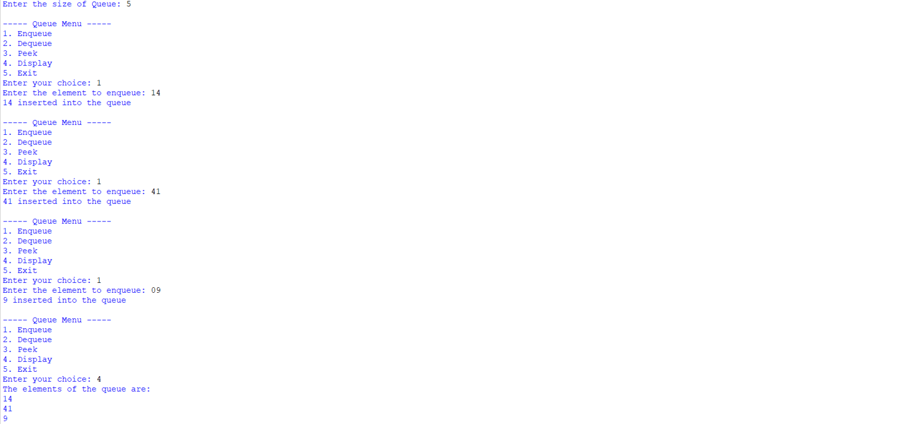
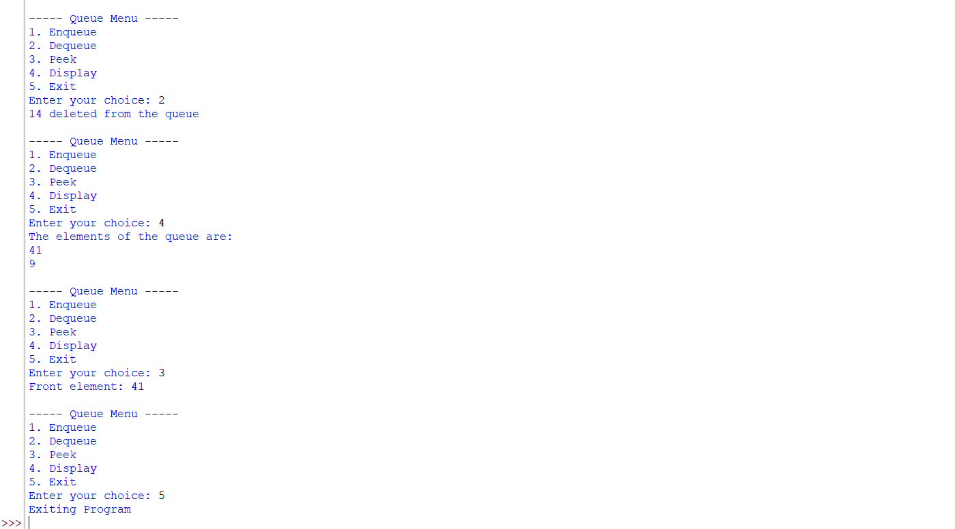
Negative Case;
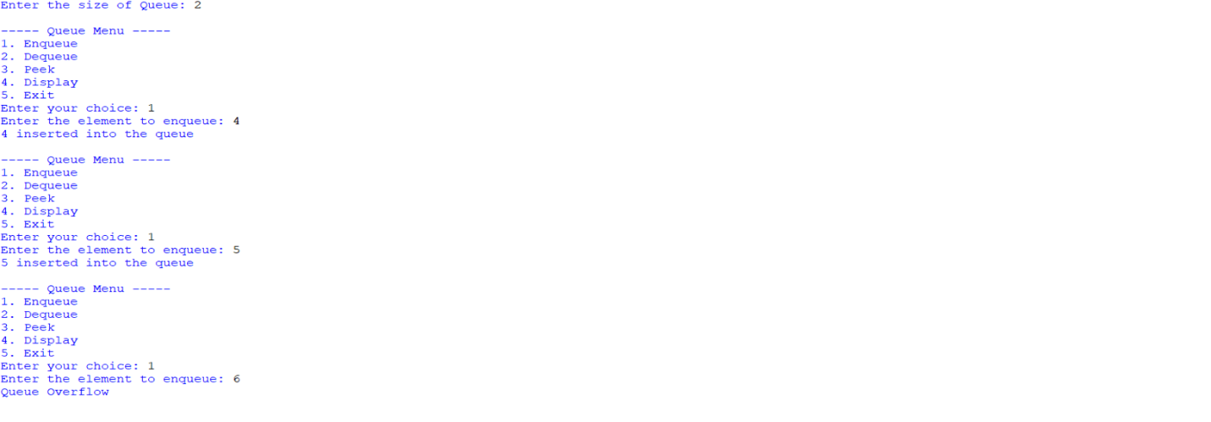
EXPLANATION:
🔹 What is a Queue?
- A Queue is a linear data structure that follows the FIFO (First In First Out) principle.
- Elements are inserted at the rear and removed from the front.
Arrays:
🔹 Components in the Code
- Initialization (__init__)
  - Creates a queue of fixed size.
  - Uses an array (self.queue) to store elements.
  - front and rear pointers track the first and last elements.
  - Both start at -1 (empty queue).
- Enqueue (Insertion)
  - Adds an element at the rear.
  - If rear == size - 1, → Overflow (queue full).
  - If queue is empty (front == -1), set front = 0.
  - Increment rear and insert the element.
- Dequeue (Deletion)
- Removes an element from the front.
- If queue is empty (front == -1 or front > rear), → Underflow.
- Deletes the element at front, increments front.
- If all elements are deleted (front > rear), reset both pointers to -1.
4. Peek
- Shows the element at the front without removing it.
- If empty, prints "Queue is empty".
5. Display
- Prints all elements between front and rear.
- If empty, prints "Queue is empty".
🔹 Menu-Driven Program
- User chooses operations from a menu:
  - Enqueue → Insert element.
  - Dequeue → Remove element.
  - Peek → Show front element.
  - Display → Show all elements.
  - Exit → End program.
- The loop continues until the user selects Exit.
🔹 Characteristics of This Queue
- It is a Linear Queue (not circular).
- Overflow occurs when rear == size - 1.
- Underflow occurs when queue is empty.
- Once rear reaches the end, no more insertions are possible even if earlier slots are freed (limitation of linear queue).
Linked List:
🔹 Structure in the Code
- Initialization (__init__)
  - Creates a queue of fixed size (default = 5).
  - Uses an array (self.queue) to store elements.
  - front and rear pointers track the first and last elements.
  - Both start at -1 (empty queue).
- Enqueue (Insertion)
  - Adds an element at the rear.
  - If rear == size - 1, → Overflow (queue full).
  - If queue is empty (front == -1), set front = 0.
  - Increment rear and insert the element.
- Dequeue (Deletion)
  - Removes an element from the front.
  - If queue is empty (front == -1), → Underflow.
  - Deletes the element at front, increments front.
  - If all elements are deleted (front > rear), reset both pointers to -1.
- Peek
  - Shows the element at the front without removing it.
  - If empty, prints "Queue is empty".
- Display
  - Prints all elements between front and rear.
  - If empty, prints "Queue is empty".
🔹 Characteristics of This Queue
- It is a Linear Queue (not circular).
- Overflow occurs when rear == size - 1.
- Underflow occurs when queue is empty (front == -1).
- Once rear reaches the end, no more insertions are possible even if earlier slots are freed (limitation of linear queue).

6b. To implement Circular Queue and its operation.
PROGRAM:
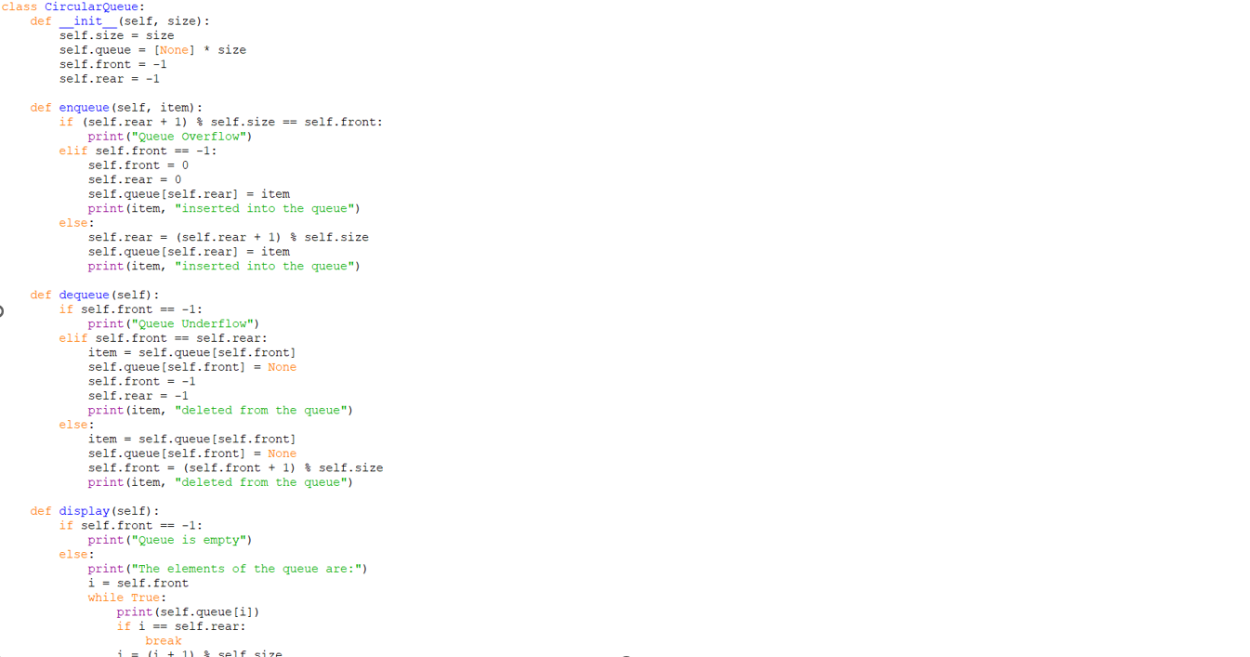
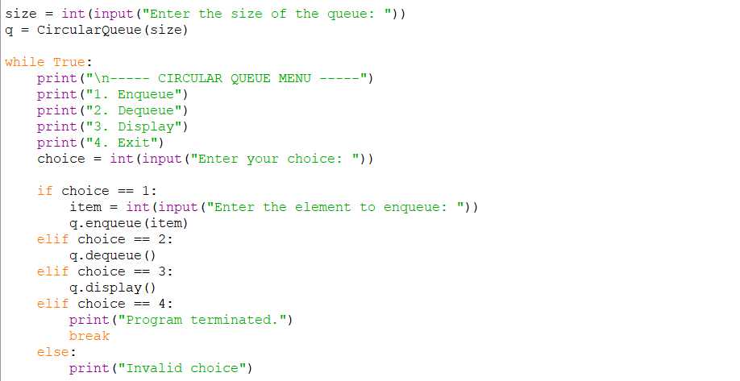
OUTPUT:
Positive Case;
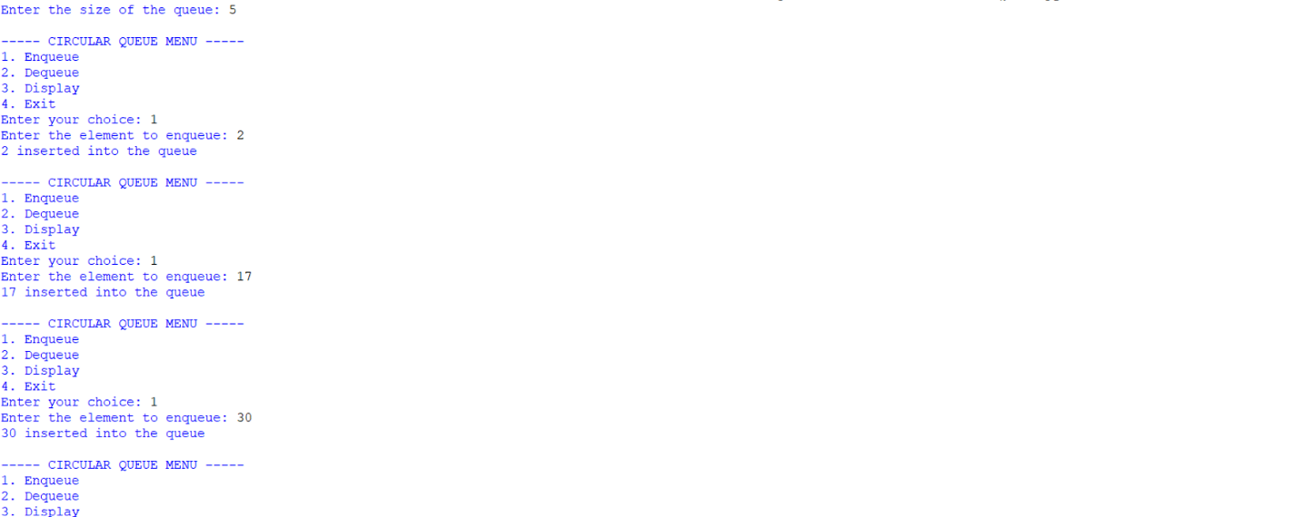
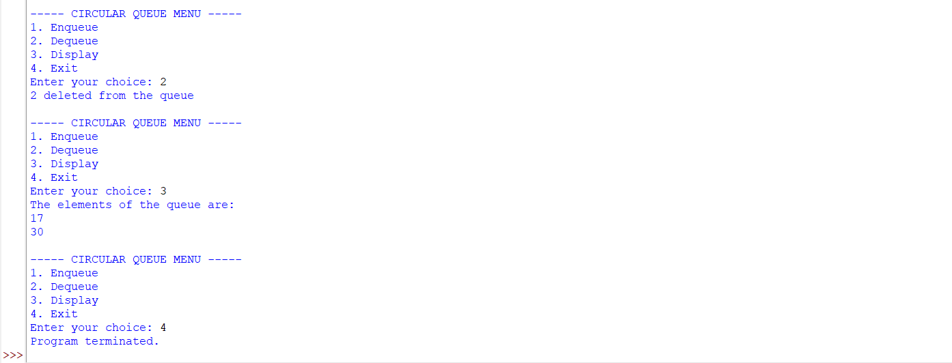
Negative Case;
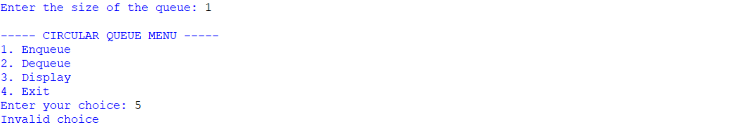
EXPLANATION:
🔹 Concept of Circular Queue
- A Circular Queue is a linear data structure that follows the FIFO (First In First Out) principle.
- Unlike a simple linear queue, the last position connects back to the first position, forming a circle.
- This design solves the problem of wasted space in a linear queue when elements are deleted from the front.
🔹 Structure in the Code
- Initialization (__init__)
  - Creates a queue of fixed size.
  - Uses an array (self.queue) to store elements.
  - front and rear pointers track the first and last elements.
  - Both start at -1 (empty queue).
- Enqueue (Insertion)
  - Adds an element at the rear.
  - Overflow occurs if (rear + 1) % size == front (queue full).
  - If queue is empty (front == -1), both front and rear are set to 0.
  - Otherwise, rear moves forward using modulo arithmetic: (rear + 1) % size.
3. Dequeue (Deletion)
- Removes an element from the front.
- Underflow occurs if front == -1 (queue empty).
- If only one element is left (front == rear), both pointers reset to -1.
- Otherwise, front moves forward using (front + 1) % size.
4.Display
- Prints all elements from front to rear using modulo arithmetic.
- Traverses circularly until it reaches the rear.
🔹 Menu-Driven Program
- User chooses operations from a menu:
  - Enqueue → Insert element.
  - Dequeue → Remove element.
  - Display → Show all elements.
  - Exit → End program.
- The loop continues until the user selects Exit.
🔹 Characteristics of Circular Queue
- Efficient use of memory: Freed spaces are reused.
- FIFO principle maintained.
- Overflow condition: (rear + 1) % size == front.
- Underflow condition: front == -1.

ERROR TABLE:
S.NO | Error Obtained | Rectification
1. | Redundant underflow check → Condition if self.front == -1 or self.front > self.rear: is slightly redundant because resetting pointers already handles empty state. | Simplify to if self.front == -1.
2. | Missing underflow condition → In dequeue, only checks if self.front == -1. If multiple deletions occur, front > rear is not handled, leading to incorrect behavior. | Add condition: if self.front == -1 or self.front > self.rear.
3. | Circular Queue: Display traversal limitation → Display prints values but not indices, making debugging harder. | Optional improvement: print both index and value.

Week-7
7)Aim:- Write a program to implement binary tree using an array and linked with all of its operations (Insertion, deletion, searching , traversal)
Program:-
a)Using Array:-
class BinaryTreeArray:

def __init__(self, size):
self.tree = [None] * size
self.size = size

def set_root(self, data):
if self.tree[0] is None:
self.tree[0] = data
else:
print("Root already exists!")
def set_left(self, parent_index, data):
child_index = 2 * parent_index + 1

if child_index < self.size:
self.tree[child_index] = data
else:
print("Index out of range!")
def set_right(self, parent_index, data):
child_index = 2 * parent_index + 2

if child_index < self.size:
self.tree[child_index] = data
else:
print("Index out of range!")
def insert(self, data):

for i in range(self.size):

if self.tree[i] is None:
self.tree[i] = data
print(data, "inserted at index", i)
return

print("Tree is full!")
def search(self, data):

for i in range(self.size):

if self.tree[i] == data:
return i

return -1
def delete(self, data):

index = self.search(data)

if index == -1:
print(data, "not found!")
return
last_index = -1

for i in range(self.size - 1, -1, -1):

if self.tree[i] is not None:
last_index = i
break
if last_index == index:
self.tree[index] = None

else:
self.tree[index] = self.tree[last_index]
self.tree[last_index] = None

print(data, "deleted!")
def preorder(self, index=0):

if index >= self.size or self.tree[index] is None:
return

print(self.tree[index], end=" ")

self.preorder(2 * index + 1)
self.preorder(2 * index + 2)
def inorder(self, index=0):

if index >= self.size or self.tree[index] is None:
return

self.inorder(2 * index + 1)

print(self.tree[index], end=" ")

self.inorder(2 * index + 2)
def postorder(self, index=0):

if index >= self.size or self.tree[index] is None:
return

self.postorder(2 * index + 1)
self.postorder(2 * index + 2)

print(self.tree[index], end=" ")
def level_order(self):

for value in self.tree:

if value is not None:
print(value, end=" ")
def display(self):

print("\nArray Representation:")

for i in range(self.size):
print("Index", i, ":", self.tree[i])
tree = BinaryTreeArray(10)
tree.set_root('A')
tree.set_left(0, 'B')
tree.set_right(0, 'C')
tree.set_left(1, 'D')
tree.set_right(1, 'E')

tree.set_right(2, 'F')

tree.display()
print("\nPreorder: ", end="")
tree.preorder()

print("\nInorder: ", end="")
tree.inorder()

print("\nPostorder: ", end="")
tree.postorder()

print("\nLevel-order: ", end="")
tree.level_order()

print("\n\nSearching for E:")

position = tree.search('E')

if position != -1:
print("Element found at index", position)
else:
print("Element not found!")

print("\nInsertion:")
tree.insert('G')

tree.display()

print("\nDeletion:")
tree.delete('D')

tree.display()
print("\nPreorder after deletion: ", end="")
tree.preorder()

print("\nInorder after deletion: ", end="")
tree.inorder()

print("\nPostorder after deletion: ", end="")
tree.postorder()

print("\nLevel-order after deletion: ", end="")
tree.level_order()
Output:-
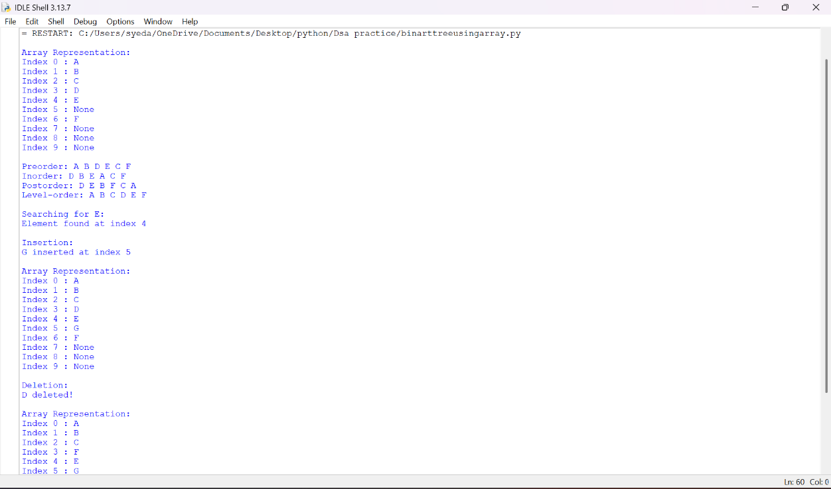
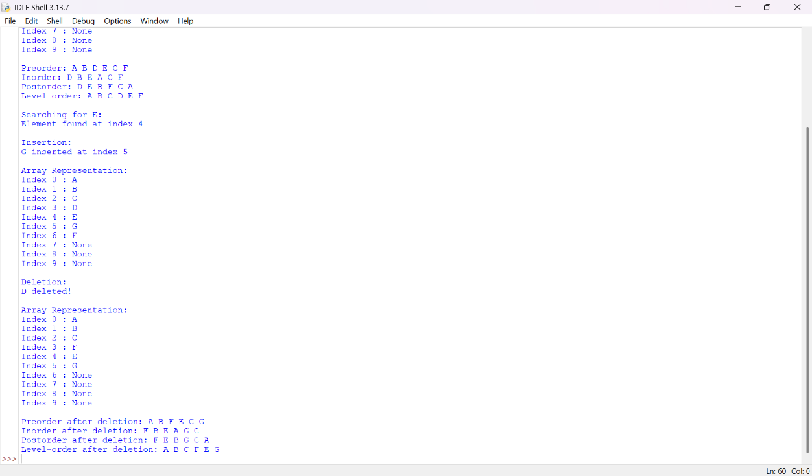
1. Binary Tree Using Array
Explanation:
This program implements a Binary Tree using an Array and performs operations such as insertion, deletion, searching, and traversal.
- Class Initialization: The class BinaryTreeArray initializes an array of a specified size, with all elements set to None.
- Setting the Root: The function set_root(data) inserts the root node at index 0 if the root does not already exist.
- Setting the Left Child: The function set_left(parent_index, data) inserts the left child at index 2 * parent_index + 1.
- Setting the Right Child: The function set_right(parent_index, data) inserts the right child at index 2 * parent_index + 2.
- Insertion: The function insert(data) searches for the first empty position in the array and inserts the new element. If no space is available, it displays a message.
- Searching: The function search(data) traverses the array and returns the index of the element if found; otherwise, it returns -1.
- Deletion: The function delete(data) searches for the element and replaces it with the last occupied element in the array. The last occupied position is then set to None.
- Preorder Traversal: The function preorder(index) visits the root, left subtree, and right subtree in that order.
- Inorder Traversal: The function inorder(index) visits the left subtree, root, and right subtree in that order.
- Postorder Traversal: The function postorder(index) visits the left subtree, right subtree, and root in that order.
- Level-Order Traversal: The function level_order() displays the elements sequentially from the array, representing level-order traversal for a properly populated array-based tree.
- Display: The function display() prints each array index along with its corresponding value.
- Main Program: The program creates a binary tree, assigns nodes, performs traversal operations, searches for an element, inserts a new element, deletes an element, and displays the updated tree.
Error Table:
S.No. | Error Obtained | Rectification
01. | Array index out of range | Check whether the child index is within the array size.
02. | Insertion when the tree is full | Check for an empty position before inserting.
03. | Element not found during searching | Return -1 if the element does not exist.
04. | Incorrect traversal output | Use the correct order of root, left subtree, and right subtree.
05. | Incorrect deletion result | Find the last occupied position and update the array carefully.
06. | Root already exists | Check whether index 0 is empty before setting the root.
07. | Child inserted without a valid parent | Verify that the parent exists before inserting a child.
b)Using linked list:-
class Node:

def __init__(self, data):
self.data = data
self.left = None
self.right = None
class BinaryTree:

def __init__(self):
self.root = None
def create_tree(self):

self.root = Node('A')
self.root.left = Node('B')
self.root.right = Node('C')
self.root.left.left = Node('D')
self.root.left.right = Node('E')
self.root.right.right = Node('F')
def insert(self, data):

new_node = Node(data)
if self.root is None:
self.root = new_node
return

queue = [self.root]

while queue:

node = queue.pop(0)
if node.left is None:
node.left = new_node
return
else:
queue.append(node.left)
if node.right is None:
node.right = new_node
return
else:
queue.append(node.right)
def search(self, data):

if self.root is None:
return None

queue = [self.root]

while queue:

node = queue.pop(0)

if node.data == data:
return node

if node.left is not None:
queue.append(node.left)

if node.right is not None:
queue.append(node.right)

return None
def delete(self, data):

if self.root is None:
print("Tree is empty!")
return
if (self.root.data == data and
self.root.left is None and
self.root.right is None):

self.root = None
print(data, "deleted!")
return

queue = [self.root]

target = None
deepest = None
parent_of_deepest = None

while queue:

node = queue.pop(0)
if node.data == data:
target = node
if node.left is not None:
parent_of_deepest = node
deepest = node.left
queue.append(node.left)

if node.right is not None:
parent_of_deepest = node
deepest = node.right
queue.append(node.right)
if target is None:
print(data, "not found!")
return
target.data = deepest.data
if parent_of_deepest.right == deepest:
parent_of_deepest.right = None
else:
parent_of_deepest.left = None

print(data, "deleted!")
def preorder(self, node):

if node is None:
return

print(node.data, end=" ")

self.preorder(node.left)
self.preorder(node.right)
def inorder(self, node):

if node is None:
return

self.inorder(node.left)

print(node.data, end=" ")

self.inorder(node.right)
def postorder(self, node):

if node is None:
return

self.postorder(node.left)
self.postorder(node.right)

print(node.data, end=" ")
def level_order(self):

if self.root is None:
return

queue = [self.root]

while queue:

node = queue.pop(0)

print(node.data, end=" ")
if node.left is not None:
queue.append(node.left)
if node.right is not None:
queue.append(node.right)

tree = BinaryTree()
tree.create_tree()
print("Preorder: ", end="")
tree.preorder(tree.root)

print("\nInorder: ", end="")
tree.inorder(tree.root)

print("\nPostorder: ", end="")
tree.postorder(tree.root)

print("\nLevel-order: ", end="")
tree.level_order()
print("\n\nSearching for E:")

result = tree.search('E')

if result is not None:
print("Element found:", result.data)
else:
print("Element not found!")

print("\nInsertion:")
tree.insert('G')

print("Level-order after insertion: ", end="")
tree.level_order()

print("\n\nDeletion:")
tree.delete('B')

print("Level-order after deletion: ", end="")
tree.level_order()
print("\n\nFinal Preorder: ", end="")
tree.preorder(tree.root)

print("\nFinal Inorder: ", end="")
tree.inorder(tree.root)

print("\nFinal Postorder: ", end="")
tree.postorder(tree.root)

print("\nFinal Level-order: ", end="")
tree.level_order()
Output:-
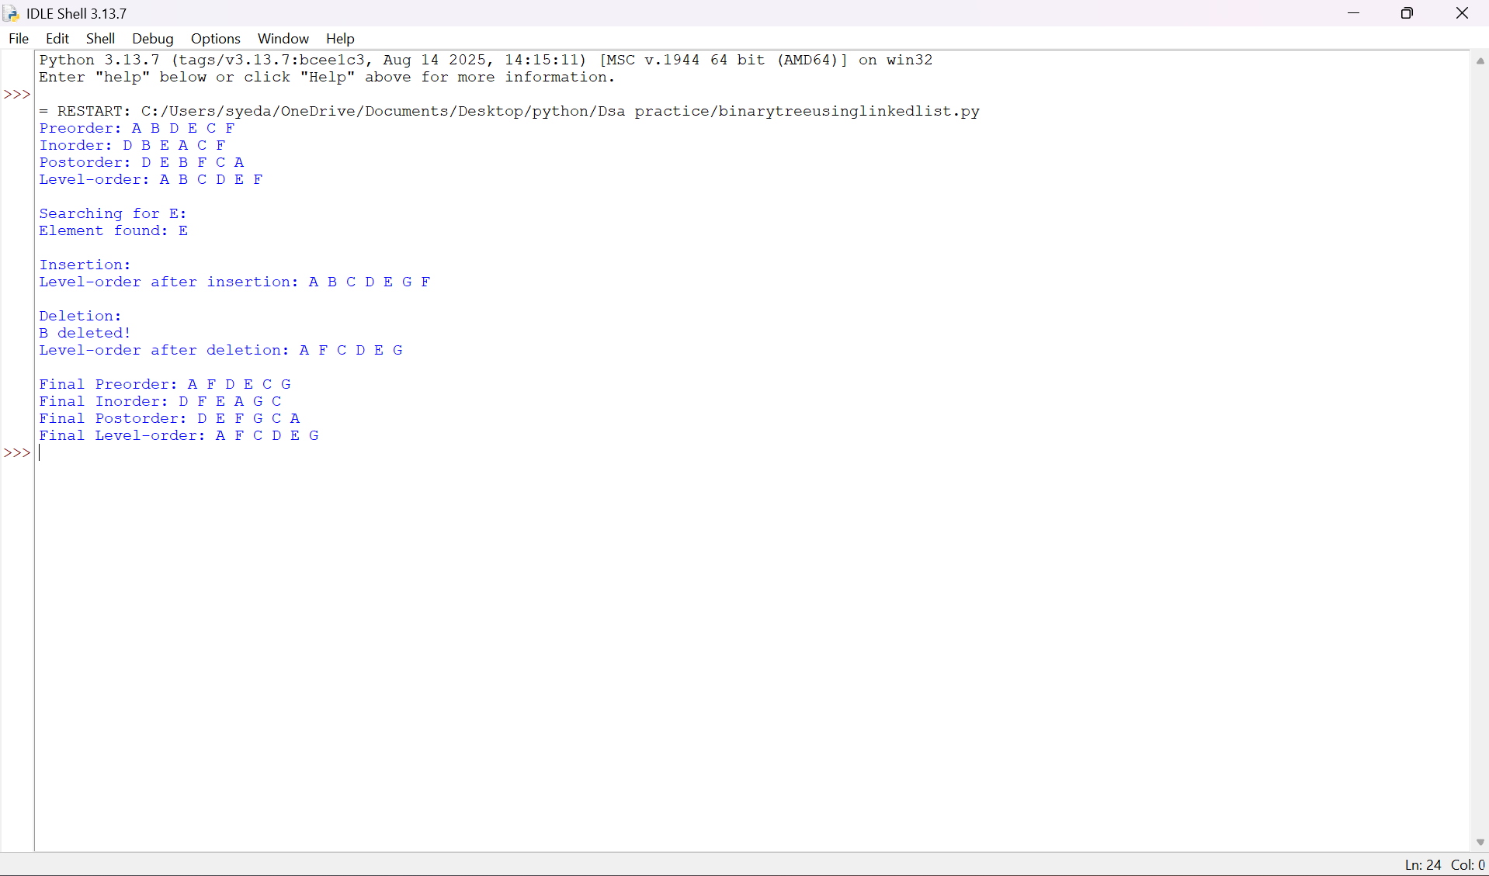
2. Binary Tree Using Linked List
Explanation:
This program implements a Binary Tree using a Linked List. Each node contains data and references to its left and right children.
- Node Class Creation: The class Node represents a tree node and contains three attributes:
  - data → stores the node value.
  - left → points to the left child.
  - right → points to the right child.
- Binary Tree Initialization: The class BinaryTree maintains a root pointer that refers to the first node of the tree.
- Tree Creation: The function create_tree() creates the binary tree by connecting nodes through their left and right pointers.
- Insertion: The function insert(data) adds a new node to the tree according to the insertion logic defined in the program.
- Deletion: The function delete(data) searches for the specified node and removes it according to the deletion logic implemented in the program.
- Searching: The function search(data) traverses the tree to locate the required element. It returns the node if found; otherwise, it returns None.
- Preorder Traversal: The function preorder(root) visits the root, left subtree, and right subtree.
- Inorder Traversal: The function inorder(root) visits the left subtree, root, and right subtree.
- Postorder Traversal: The function postorder(root) visits the left subtree, right subtree, and root.
- Level-Order Traversal: The function level_order() uses a queue to visit nodes level by level. It adds the left and right children of each visited node to the queue.
- Main Program: The program creates the binary tree, performs all four traversal operations, searches for an element, inserts a new node, deletes a node, and displays the updated traversal results.
Error Table:
S.No. | Error Obtained | Rectification
01. | AttributeError when accessing an empty node | Check whether the node is None before accessing its attributes.
02. | Incorrect left or right child connection | Assign the appropriate left and right pointers.
03. | Element not found during searching | Return None when the element does not exist.
04. | Incorrect traversal output | Follow the correct traversal sequence.
05. | Level-order traversal fails | Initialize the queue with the root and check for empty nodes.
06. | Incorrect deletion of a node | Handle leaf nodes, nodes with children, and root deletion appropriately.
07. | Duplicate or missing nodes during insertion | Follow the defined insertion rules and check existing nodes when necessary.

Week-8
Aim:- To write a Python program to implement a Binary Search Tree (BST) and perform operations such as insertion, deletion, searching, and tree traversals (inorder, preorder, postorder, and level-order).
Program:-
8A Binary search tree:-
class Node:
def __init__(self, data):
self.data = data
self.left = None
self.right = None

# Insert a node
def insert(root, data):
if root is None:
return Node(data)

if data < root.data:
root.left = insert(root.left, data)
elif data > root.data:
root.right = insert(root.right, data)

return root

# Search for a node
def search(root, key):
if root is None or root.data == key:
return root

if key < root.data:
return search(root.left, key)

return search(root.right, key)

# Find minimum value
def find_min(root):
while root.left:
root = root.left
return root

# Delete a node
def delete(root, key):
if root is None:
return None

if key < root.data:
root.left = delete(root.left, key)

elif key > root.data:
root.right = delete(root.right, key)

else:
if root.left is None:
return root.right

if root.right is None:
return root.left

temp = find_min(root.right)
root.data = temp.data
root.right = delete(root.right, temp.data)

return root

# Inorder traversal
def inorder(root):
if root:
inorder(root.left)
print(root.data, end=" ")
inorder(root.right)

# Preorder traversal
def preorder(root):
if root:
print(root.data, end=" ")
preorder(root.left)
preorder(root.right)

# Postorder traversal
def postorder(root):
if root:
postorder(root.left)
postorder(root.right)
print(root.data, end=" ")

# Level-order traversal
def level_order(root):
if root is None:
return

queue = [root]

while queue:
node = queue.pop(0)
print(node.data, end=" ")

if node.left:
queue.append(node.left)

if node.right:
queue.append(node.right)

# Main program
root = None

values = [50, 30, 70, 20, 40, 60, 80]

for value in values:
root = insert(root, value)

print("Inorder Traversal:")
inorder(root)

print("\nPreorder Traversal:")
preorder(root)

print("\nPostorder Traversal:")
postorder(root)

print("\nLevel-order Traversal:")
level_order(root)

key = 40
print("\n\nSearching for", key)

if search(root, key):
print("Element found")
else:
print("Element not found")

print("\nDeleting 30")
root = delete(root, 30)

print("Inorder after deletion:")
inorder(root)

print("\n\nInserting 25")
root = insert(root, 25)

print("Inorder after insertion:")
inorder(root)
print()
Output:-
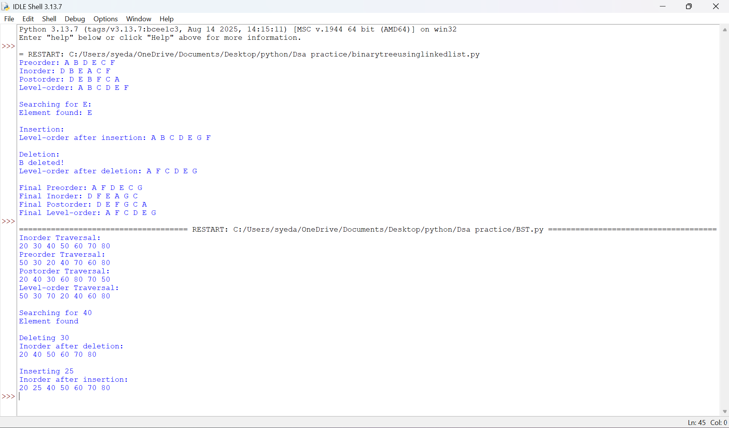
8A. Explanation: Binary Search Tree (BST)
This program implements a Binary Search Tree (BST) using Python and performs insertion, deletion, searching, and tree traversal operations.
- Node Creation: The class Node creates a node containing data and references to its left and right children.
- Insertion: The function insert(root, data) inserts a new node. Smaller values are placed in the left subtree, while larger values are placed in the right subtree.
- Searching: The function search(root, key) searches for an element by comparing it with the current node and moving to the left or right subtree accordingly.
- Finding Minimum: The function find_min(root) finds the smallest value by traversing the left subtree until the leftmost node is reached.
- Deletion: The function delete(root, key) removes a node. It handles nodes with no children, one child, or two children while maintaining the BST property.
- Inorder Traversal: The function inorder(root) visits the left subtree, root, and right subtree, displaying values in ascending order.
- Preorder Traversal: The function preorder(root) visits the root, left subtree, and right subtree.
- Postorder Traversal: The function postorder(root) visits the left subtree, right subtree, and root.
- Level-Order Traversal: The function level_order(root) uses a queue to visit nodes level by level.
- Main Program: The program creates a BST using predefined values and performs all four traversals, searches for an element, deletes a node, inserts a new node, and displays the updated traversal results.

8A. Error Table – Binary Search Tree (BST)
S. No. | Error | Cause | Correction
1 | AttributeError | Accessing a node that is None. | Check whether the node exists before accessing its attributes.
2 | NameError | Using an undefined variable or function. | Declare the variable or define the function before using it.
3 | TypeError | Comparing incompatible data types. | Ensure the values being compared have compatible data types.
4 | Incorrect traversal output | Using the wrong order of visiting nodes. | Follow the correct traversal sequence: inorder, preorder, or postorder.
5 | Incorrect deletion | Not handling all deletion cases. | Handle nodes with no children, one child, and two children.
8B)Aim:- To write a Python program to implement an AVL Tree and perform operations such as insertion, deletion, searching, and tree traversals (inorder, preorder, postorder, and level-order), maintaining the balance of the tree using rotations.
Program:-
class Node:
def __init__(self, data):
self.data = data
self.left = None
self.right = None
self.height = 1

# Calculate height
def height(node):
if node is None:
return 0
return node.height

# Calculate balance factor
def balance_factor(node):
if node is None:
return 0
return height(node.left) - height(node.right)

# Right rotation
def right_rotate(y):
x = y.left
t2 = x.right

x.right = y
y.left = t2

y.height = 1 + max(height(y.left), height(y.right))
x.height = 1 + max(height(x.left), height(x.right))

return x

# Left rotation
def left_rotate(x):
y = x.right
t2 = y.left

y.left = x
x.right = t2

x.height = 1 + max(height(x.left), height(x.right))
y.height = 1 + max(height(y.left), height(y.right))

return y

# Insert a node
def insert(root, data):
if root is None:
return Node(data)

if data < root.data:
root.left = insert(root.left, data)

elif data > root.data:
root.right = insert(root.right, data)

else:
return root

root.height = 1 + max(height(root.left), height(root.right))

bf = balance_factor(root)

# LL Case
if bf > 1 and data < root.left.data:
return right_rotate(root)

# RR Case
if bf < -1 and data > root.right.data:
return left_rotate(root)

# LR Case
if bf > 1 and data > root.left.data:
root.left = left_rotate(root.left)
return right_rotate(root)

# RL Case
if bf < -1 and data < root.right.data:
root.right = right_rotate(root.right)
return left_rotate(root)

return root

# Search for a node
def search(root, key):
if root is None or root.data == key:
return root

if key < root.data:
return search(root.left, key)

return search(root.right, key)

# Find minimum node
def find_min(root):
while root.left:
root = root.left
return root

# Delete a node and rebalance
def delete(root, key):
if root is None:
return None

if key < root.data:
root.left = delete(root.left, key)

elif key > root.data:
root.right = delete(root.right, key)

else:
if root.left is None:
return root.right

elif root.right is None:
return root.left

temp = find_min(root.right)
root.data = temp.data
root.right = delete(root.right, temp.data)

if root is None:
return None

root.height = 1 + max(height(root.left), height(root.right))

bf = balance_factor(root)

# LL Case
if bf > 1 and balance_factor(root.left) >= 0:
return right_rotate(root)

# LR Case
if bf > 1 and balance_factor(root.left) < 0:
root.left = left_rotate(root.left)
return right_rotate(root)

# RR Case
if bf < -1 and balance_factor(root.right) <= 0:
return left_rotate(root)

# RL Case
if bf < -1 and balance_factor(root.right) > 0:
root.right = right_rotate(root.right)
return left_rotate(root)

return root

# Inorder traversal
def inorder(root):
if root:
inorder(root.left)
print(root.data, end=" ")
inorder(root.right)

# Preorder traversal
def preorder(root):
if root:
print(root.data, end=" ")
preorder(root.left)
preorder(root.right)

# Postorder traversal
def postorder(root):
if root:
postorder(root.left)
postorder(root.right)
print(root.data, end=" ")

# Level-order traversal
def level_order(root):
if root is None:
return

queue = [root]

while queue:
node = queue.pop(0)
print(node.data, end=" ")

if node.left:
queue.append(node.left)

if node.right:
queue.append(node.right)

# Main program
root = None

values = [10, 20, 30, 40, 50, 25]

for value in values:
root = insert(root, value)

print("Inorder Traversal:")
inorder(root)

print("\nPreorder Traversal:")
preorder(root)

print("\nPostorder Traversal:")
postorder(root)

print("\nLevel-order Traversal:")
level_order(root)

key = 30
print("\n\nSearching for", key)

if search(root, key):
print("Element found")
else:
print("Element not found")

print("\nDeleting 40")
root = delete(root, 40)

print("Inorder after deletion:")
inorder(root)

print("\n\nInserting 35")
root = insert(root, 35)

print("Inorder after insertion:")
inorder(root)
print()
Output:-
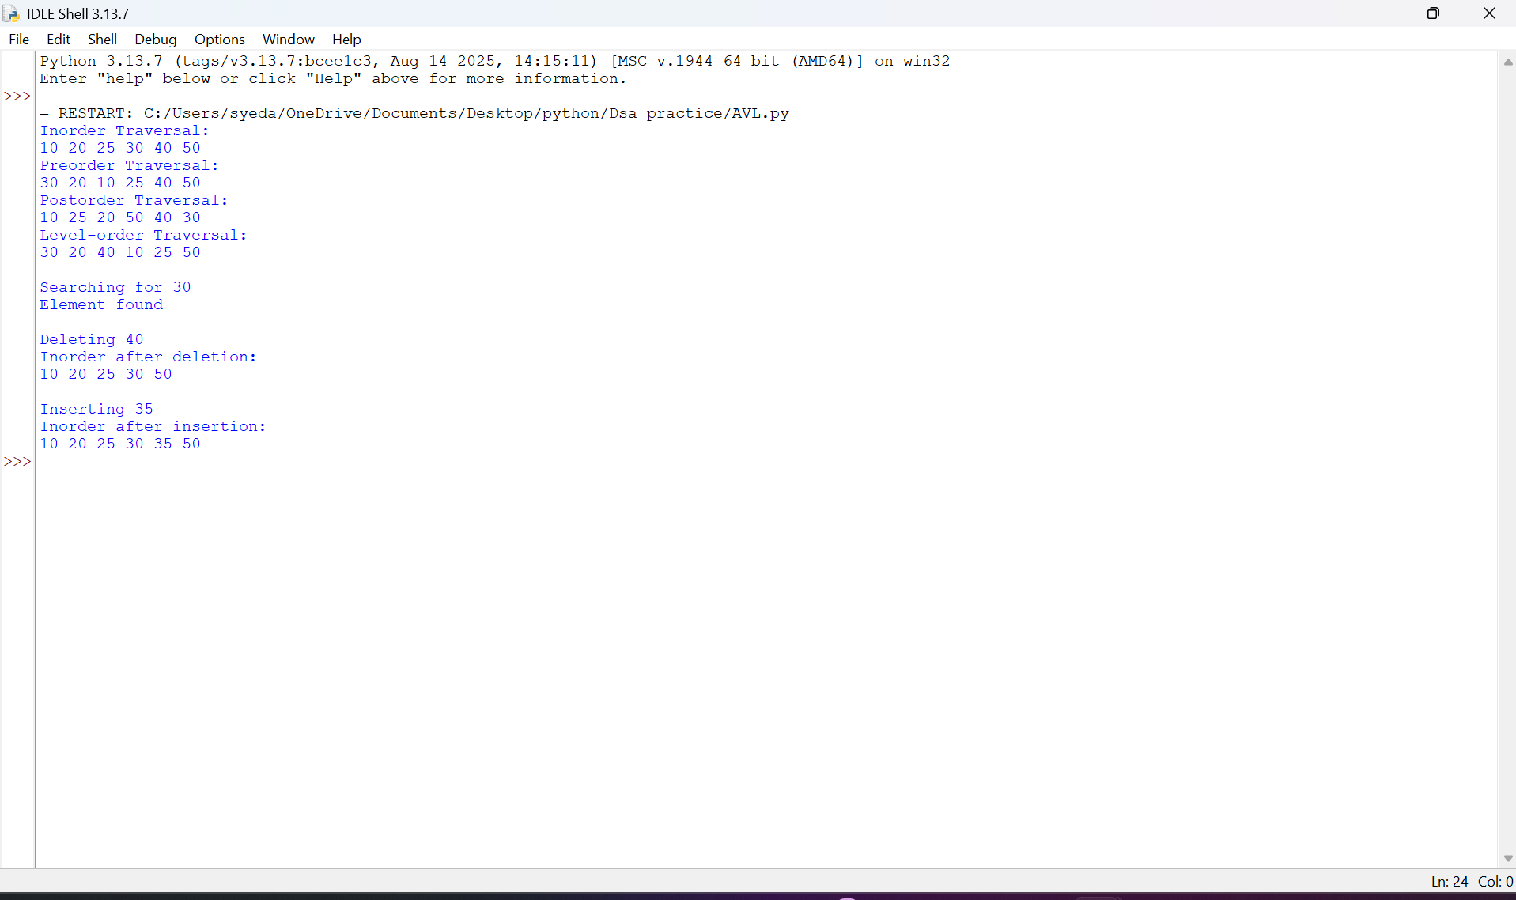
8B. Explanation: AVL Tree
This program implements an AVL Tree, a self-balancing Binary Search Tree, using Python. It performs insertion, deletion, searching, and tree traversal operations while maintaining the balance of the tree.
- Node Creation: The class Node creates a node containing data, left and right child references, and a height value initialized to 1.
- Height Calculation: The function height(node) returns the height of a node. If the node is None, it returns 0.
- Balance Factor: The function balance_factor(node) calculates the difference between the heights of the left and right subtrees. An AVL tree maintains a balance factor of -1, 0, or 1 at every node.
- Right Rotation: The function right_rotate(y) performs a right rotation to restore balance when required.
- Left Rotation: The function left_rotate(x) performs a left rotation to restore balance when required.
- Insertion: The function insert(root, data) inserts a node according to BST rules, updates node heights, calculates the balance factor, and performs rotations when necessary.
- Balancing Cases: The insertion function handles four cases:
  - LL (Left-Left): Performs a right rotation.
  - RR (Right-Right): Performs a left rotation.
  - LR (Left-Right): Performs a left rotation followed by a right rotation.
  - RL (Right-Left): Performs a right rotation followed by a left rotation.
- Searching: The function search(root, key) searches for an element by comparing values and moving through the appropriate subtree.
- Finding Minimum: The function find_min(root) finds the smallest value by traversing the leftmost nodes.
- Deletion: The function delete(root, key) removes a node while maintaining BST properties. It updates heights and performs the required rotations to restore AVL balance.
- Inorder Traversal: The function inorder(root) visits the left subtree, root, and right subtree, displaying values in ascending order.
- Preorder Traversal: The function preorder(root) visits the root, left subtree, and right subtree.
- Postorder Traversal: The function postorder(root) visits the left subtree, right subtree, and root.
- Level-Order Traversal: The function level_order(root) uses a queue to visit nodes level by level.
- Main Program: The program creates an AVL tree using predefined values and performs all four traversals, searches for an element, deletes a node, inserts a new node, and displays the updated traversal results.

Key difference: A BST does not automatically balance itself, whereas an AVL tree uses rotations after insertion and deletion to maintain balance and provide efficient operations.
8B. Error Table – AVL Tree
S. No. | Error | Cause | Correction
1 | AttributeError | Accessing attributes of a None node. | Check whether the node is None before accessing its attributes.
2 | NameError | Using an undefined function or variable. | Define all required functions and variables before using them.
3 | Incorrect height | Not updating the node height after insertion or deletion. | Recalculate the height after modifying the tree.
4 | Unbalanced tree | Applying an incorrect rotation. | Identify the LL, RR, LR, or RL case and apply the appropriate rotation.
5 | Incorrect deletion | Failing to rebalance the tree after deletion. | Update heights, calculate balance factors, and perform rotations when required.
6 | Incorrect traversal output | Visiting nodes in the wrong order. | Follow the correct traversal sequence for each traversal method.

Week-9
AIM:- To write a Python program to implement a Hash Table and perform various hashing operations such as insertion, searching, deletion, displaying elements, calculating load factor, handling collisions using Separate Chaining, Linear Probing, Quadratic Probing and Double Hashing, and performing Rehashing.
PROGRAM
The following implementation allows you to select:
- A hashing method.
- A collision resolution technique.
- Different hash table operations.
SIZE = 11
EMPTY = None
DELETED = "DELETED"

# Select Hash Function
print("HASH FUNCTIONS")
print("1. Index Mapping")
print("2. Division Method")
print("3. Mid-Square Method")
print("4. Digit Folding Method")
print("5. Multiplication Method")

hf = int(input("Select hash function: "))

# Select Collision Resolution
print("\nCOLLISION RESOLUTION")
print("1. Separate Chaining")
print("2. Linear Probing")
print("3. Quadratic Probing")
print("4. Double Hashing")

cr = int(input("Select collision method: "))

table = [[] for i in range(SIZE)] if cr == 1 else [EMPTY] * SIZE

# Hash Functions
def hash_function(key):
if hf == 1:
return key % SIZE

elif hf == 2:
return key % SIZE

elif hf == 3:
square = str(key * key)
width = len(str(SIZE - 1))
start = max(0, (len(square) - width) // 2)
return int(square[start:start + width]) % SIZE

elif hf == 4:
s = str(key)
parts = [int(s[i:i + 3]) for i in range(0, len(s), 3)]
return sum(parts) % SIZE

elif hf == 5:
c = 0.618
product = key * c
fraction = product - int(product)
return int(SIZE * fraction)

def second_hash(key):
return 7 - (key % 7)

# Find Index
def find_index(key):
index = hash_function(key)

for i in range(SIZE):
if cr == 1:
return index

elif cr == 2:
pos = (index + i) % SIZE

elif cr == 3:
pos = (index + i * i) % SIZE

else:
pos = (index + i * second_hash(key)) % SIZE

if table[pos] is EMPTY:
return pos

if table[pos] == DELETED:
continue

if table[pos][0] == key:
return pos

return -1

# Insert
def insert(key, value):
index = hash_function(key)

if cr == 1:
for i in range(len(table[index])):
if table[index][i][0] == key:
table[index][i] = (key, value)
print("Value updated.")
return

table[index].append((key, value))
print("Element inserted.")

else:
pos = find_index(key)

if pos == -1:
print("Hash table is full.")
return

if table[pos] is not EMPTY and table[pos] != DELETED:
table[pos] = (key, value)
print("Value updated.")
else:
table[pos] = (key, value)
print("Element inserted.")

if load_factor() > 0.7:
rehash()

# Search
def search(key):
index = hash_function(key)

if cr == 1:
for k, v in table[index]:
if k == key:
print("Key found. Value:", v)
return

else:
for i in range(SIZE):
if cr == 2:
pos = (index + i) % SIZE
elif cr == 3:
pos = (index + i * i) % SIZE
else:
pos = (index + i * second_hash(key)) % SIZE

if table[pos] is EMPTY:
break

if table[pos] != DELETED and table[pos][0] == key:
print("Key found. Value:", table[pos][1])
return

print("Key not found.")

# Delete
def delete(key):
index = hash_function(key)

if cr == 1:
for i in range(len(table[index])):
if table[index][i][0] == key:
table[index].pop(i)
print("Element deleted.")
return

else:
for i in range(SIZE):
if cr == 2:
pos = (index + i) % SIZE
elif cr == 3:
pos = (index + i * i) % SIZE
else:
pos = (index + i * second_hash(key)) % SIZE

if table[pos] is EMPTY:
break

if table[pos] != DELETED and table[pos][0] == key:
table[pos] = DELETED
print("Element deleted.")
return

print("Key not found.")

# Display
def display():
print("\nHASH TABLE")

for i in range(SIZE):
print(i, ":", table[i])

# Load Factor
def load_factor():
if cr == 1:
count = sum(len(bucket) for bucket in table)
else:
count = sum(
1 for item in table
if item is not EMPTY and item != DELETED
)

return count / SIZE

# Rehashing
def rehash():
global SIZE, table

old_table = table

SIZE = SIZE * 2 + 1

if cr == 1:
table = [[] for i in range(SIZE)]
else:
table = [EMPTY] * SIZE

if cr == 1:
for bucket in old_table:
for key, value in bucket:
insert_without_rehash(key, value)
else:
for item in old_table:
if item is not EMPTY and item != DELETED:
insert_without_rehash(item[0], item[1])

print("Hash table rehashed. New size:", SIZE)

# Insert without triggering another rehash
def insert_without_rehash(key, value):
index = hash_function(key)

if cr == 1:
table[index].append((key, value))

else:
for i in range(SIZE):
if cr == 2:
pos = (index + i) % SIZE
elif cr == 3:
pos = (index + i * i) % SIZE
else:
pos = (index + i * second_hash(key)) % SIZE

if table[pos] is EMPTY:
table[pos] = (key, value)
return

# Main Menu
while True:
print("\n===== HASH TABLE OPERATIONS =====")
print("1. Insert")
print("2. Search")
print("3. Delete")
print("4. Display")
print("5. Load Factor")
print("6. Rehash")
print("7. Exit")

choice = int(input("Enter choice: "))

if choice == 1:
key = int(input("Enter key: "))
value = input("Enter value: ")
insert(key, value)

elif choice == 2:
key = int(input("Enter key to search: "))
search(key)

elif choice == 3:
key = int(input("Enter key to delete: "))
delete(key)

elif choice == 4:
display()

elif choice == 5:
print("Load Factor:", load_factor())

elif choice == 6:
rehash()

elif choice == 7:
print("Program terminated.")
break

else:
print("Invalid choice.")
Output:-
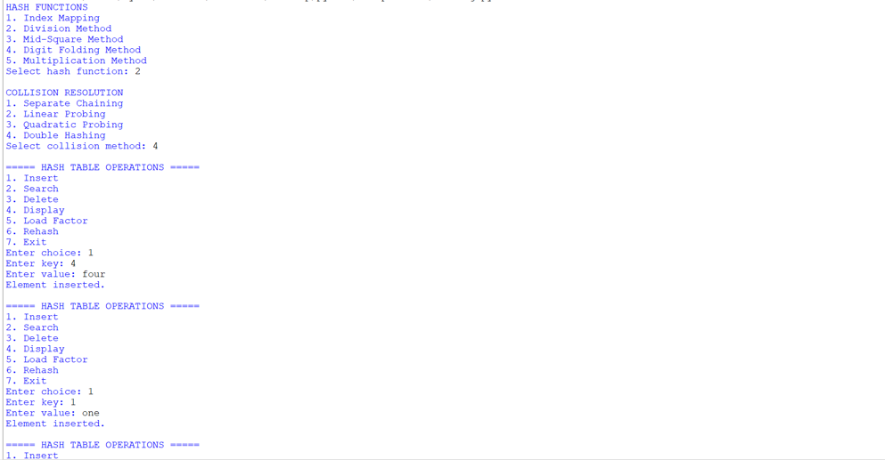
Negative case:-
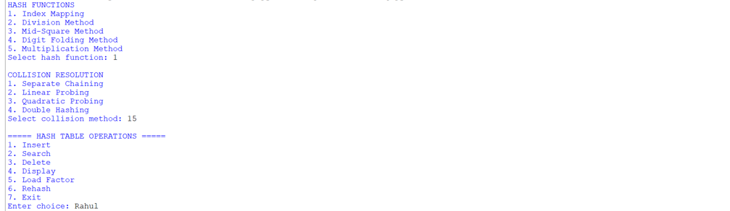

Negative case because:-
Insert key 15 with value Rahul.
Using Division Method: 15 % 11 = 4. The pair is stored at index 4.
Search for key 99.
Its hash index is 99 % 11 = 0.
Index 0 is empty, so the program displays "Key not found."
EXPLANATION
- Hash Table Creation: An array-like structure is created with an initial size of 11. Each position represents a slot in the hash table.
- Hash Function: The hash_function() calculates the index where a key should be stored. It supports five methods:
  - Index Mapping
  - Division Method
  - Mid-Square Method
  - Digit Folding Method
  - Multiplication Method
- Index Mapping: Assigns a key to an index using a predefined mapping. It is suitable when keys belong to a small, known range.
- Division Method: Calculates the index using the remainder of the key divided by the table size.
h(x) = x % SIZE
- Mid-Square Method: Squares the key and extracts the middle digits to obtain the hash index.
- Digit Folding Method: Divides the key into smaller parts and adds those parts to generate a hash value.
- Multiplication Method: Multiplies the key by a constant between 0 and 1, extracts the fractional part, and multiplies it by the table size.
- Collision Handling: A collision occurs when two different keys generate the same hash index. The program supports four collision resolution techniques.
- Separate Chaining: Stores multiple key-value pairs in a list associated with the same hash index.
- Linear Probing: Searches for the next available position sequentially when a collision occurs.
- Quadratic Probing: Searches for an available position using the square of the probe number to reduce clustering.
- Double Hashing: Uses a second hash function to calculate the interval between successive positions when collisions occur.
- Insertion: The insert() function calculates the hash index and stores the key-value pair. If the key already exists, its value is updated.
- Searching: The search() function calculates the index and searches for the required key using the selected collision resolution technique.
- Deletion: The delete() function removes the specified key. In open addressing, a deleted marker is used so that searching for other keys continues correctly.
- Display: The display() function prints all the positions and their corresponding values.
- Load Factor: The load_factor() function calculates how full the hash table is.
α = Number of occupied slots / Total number of slots
- Rehashing: The rehash() function creates a larger hash table and inserts all existing elements again after recalculating their indices.
- Main Menu: A while loop allows the user to repeatedly perform the operations until Exit is selected.
Important Formulae:-
Method | Formula
Division | h(x) = x % M
Mid-Square | Square the key and extract middle digits
Digit Folding | Add the separate parts of the key
Multiplication | h(x) = floor(M × fractional(x × C))
Linear Probing | (h(x) + i) % M
Quadratic Probing | (h(x) + i²) % M
Double Hashing | (h1(x) + i × h2(x)) % M
Load Factor | α = n / M

Time complexity:-
Operation | Average Case | Worst Case
Insertion | O(1) | O(n)
Searching | O(1) | O(n)
Deletion | O(1) | O(n)
Display | O(n + M) | O(n + M)
Load Factor | O(n + M) | O(n + M)
Rehashing | O(n) | O(n)
SPACE COMPLEXITY: O(n + M)
Error Table – Week 9: Hashing:-
S.No. | Error | Rectification
1 | Searching for a missing key. | Display "Key not found."
2 | Deleting a missing key. | Check whether the key exists.
3 | Inserting duplicate keys. | Update the existing value.
4 | Collision occurs. | Apply a collision resolution technique.
5 | Hash table becomes full. | Perform rehashing.
6 | Incorrect hash index. | Ensure the index is within table size.

!<-----THE END----->!

